CHAPTER 1: BASIC CONCEPTS OF PROBABILITY

* Basic probability concepts and definitions
* Operations of events
  + Complement events, mutually exclusive events
  + Union of events, intersection of events
* Counting methods
  + Multiplication principle
  + Addition principle
* Permutation
* Combination
* Approaches to probability
  + Classical, relative frequency, subjective
* Axioms of probability
* Basic properties of probability
* Conditional probability
* Multiplicative rule of probability
* The Law of Total Probability
* Bayes’ Theorem
* Independent events

CHAPTER 2: CONCEPTS OF RANDOM VARIABLES

* Random variables
* Discrete probability distributions (probability function)
* Continuous probability distributions (probability density function)
* Cumulative distribution function
* Expectation
  + Mean, variance
  + Expectation of functions of random variables
  + Properties of expectation
* Chebychev’s Inequality

CHAPTER 3: 2-D RANDOM VARIABLES AND CONDITIONAL PROBABILITY DISTRIBUTIONS

* 2 dimensional random variables
* Joint probability functions for discrete random variables
* Joint probability density functions for continuous random variables
* Marginal distributions
* Conditional distributions
* Independent random variables
* Expectation

CHAPTER 4: SPECIAL PROBABILITY DISTRIBUTIONS

* Discrete distributions
  + Discrete uniform distribution
  + Bernoulli and Binomial distributions
  + Negative binomial distribution
  + Poisson distribution
  + Poisson approximation to Binomial distribution
* Continuous distributions
  + Continuous uniform distribution
  + Exponential distribution
  + Normal distribution
  + Normal approximation to Binomial distribution

CHAPTER 5: SAMPLING & SAMPLING DISTRIBUTIONS

* Population and sample
* Random sampling
* Sampling distribution of sample mean
* CLT and applications
* Sampling distribution of difference of two sample means
* Chi-square distribution
* Sampling distribution of $\frac{\left(n-1\right)S^{2}}{{}^{2}}$
* t-distribution
* F-distribution

CHAPTER 6: ESTIMATION BASED ON NORMAL DISTRIBUTION

* Point estimation
* Parameter and statistic
* Unbiased estimator
* Interval estimation
* Confidence interval for the mean
* Sample size
* Confidence intervals for the difference between two means
* Confidence interval for variances and ratio of variances

CHAPTER 7: HYPOTHESIS TESTING BASED ON NORMAL DISTRIBUTION

* Hypothesis testing based on Normal distribution
* Type I and II Error
* Level of significance
* Hypotheses testing concerning mean
* Critical value approach and p-value approach
* Hypotheses testing concerning difference between two means
* Hypothesis testing concerning variances

CHAPTER 1: BASIC CONCEPTS OF PROBABILITY

Union and Intersection Events

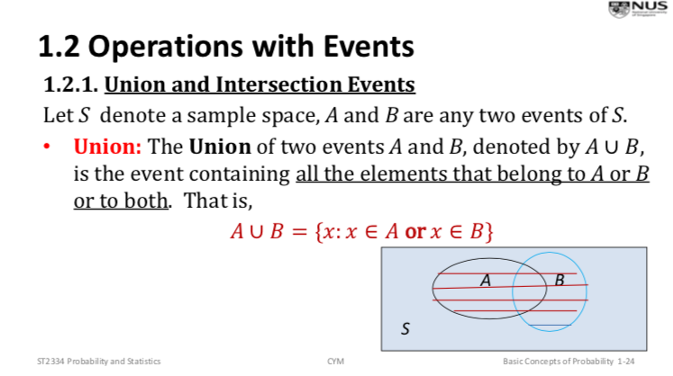

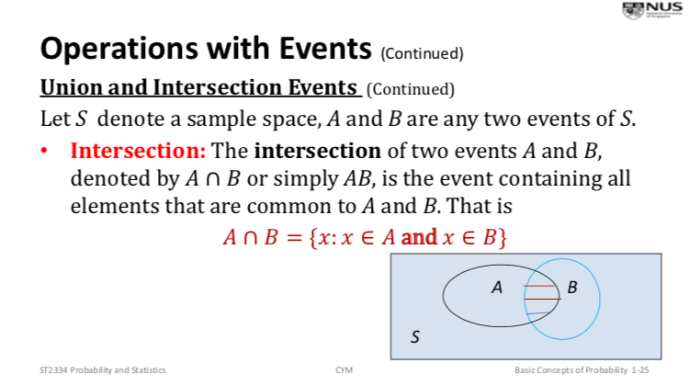

Complement Event

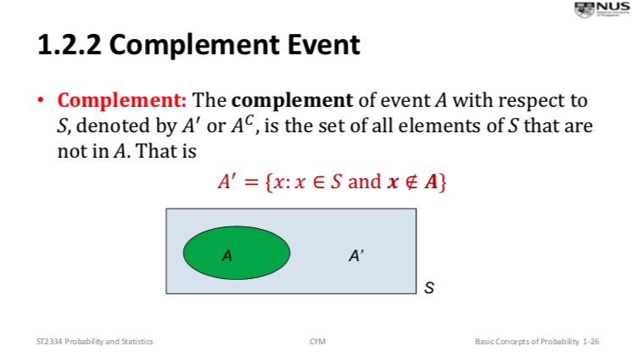

Mutually Exclusive Events

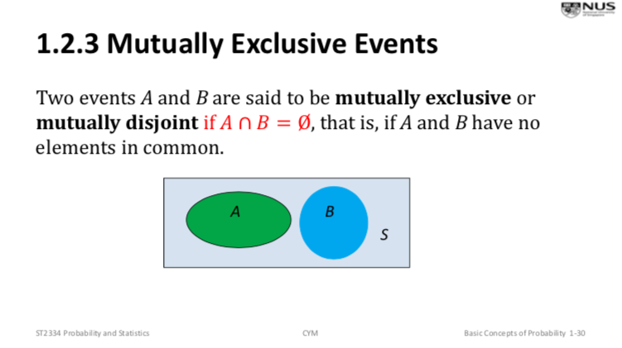

Union and Intersection of n Events

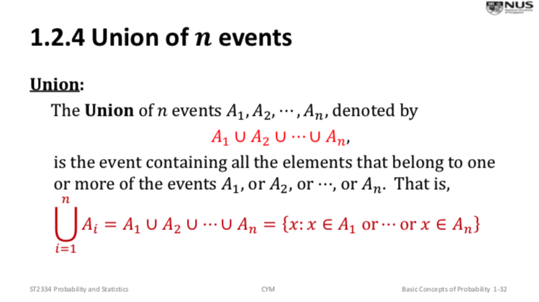

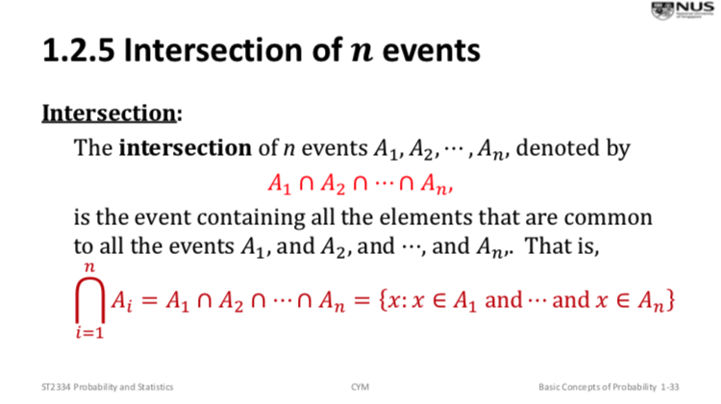

Basic Properties of Operations of Events

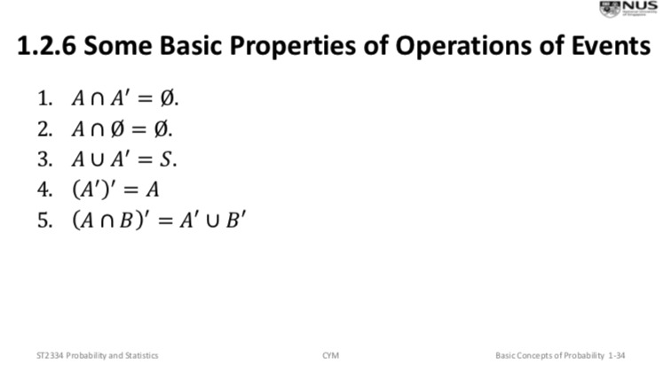

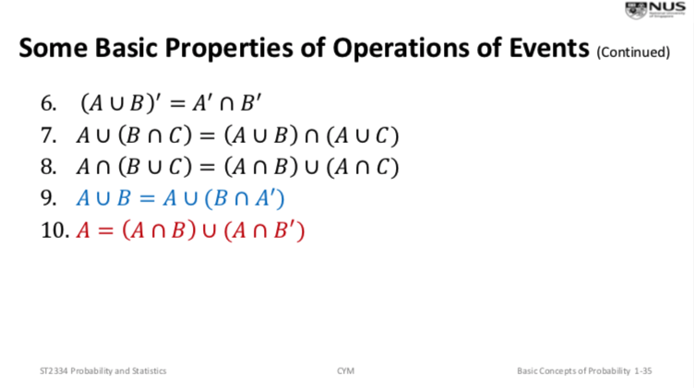

Note: A U B = (A’ INTERSECT B’)’

Note: A’ U B’ = (A INTERSECT B)’

De Morgan’s Law

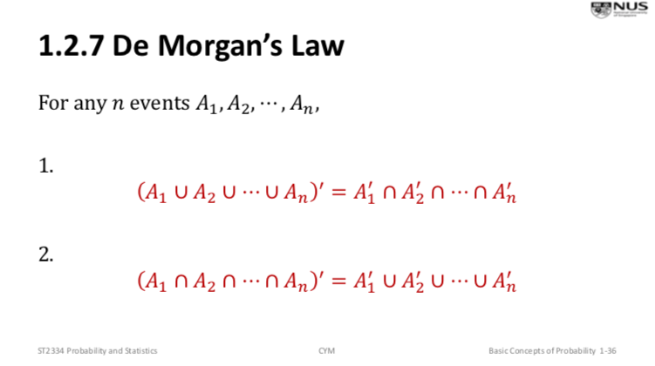

Contains

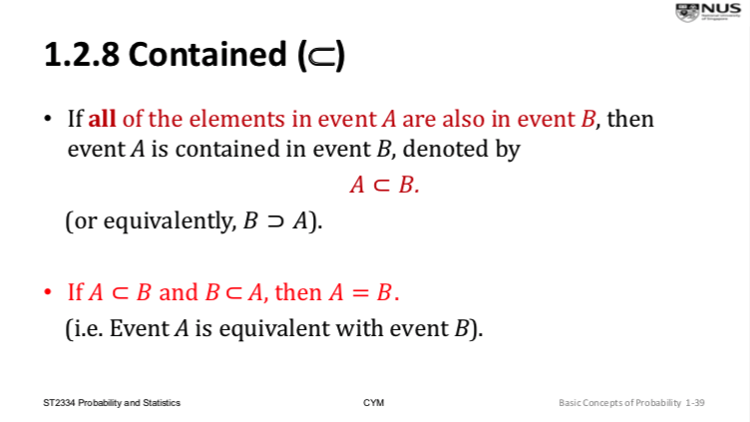

Counting methods: Multiplication Principle

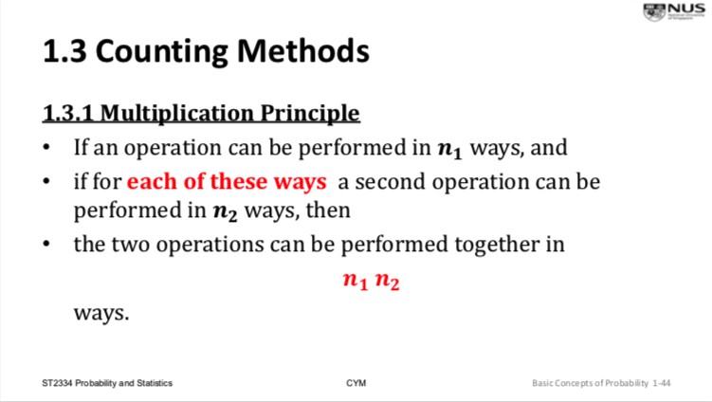

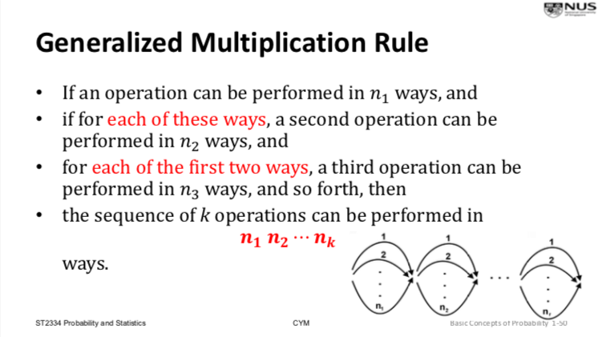

Addition Principle

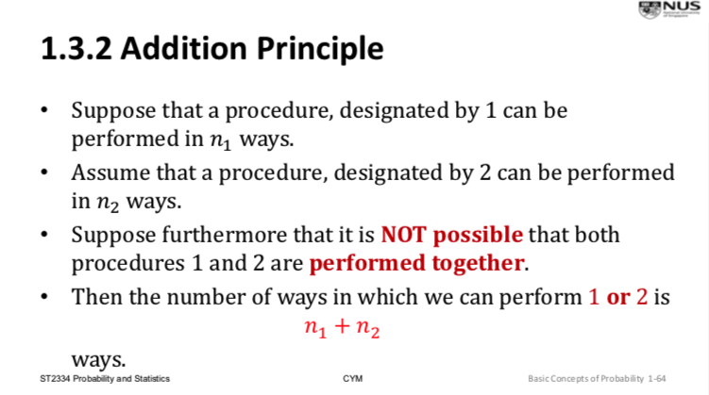

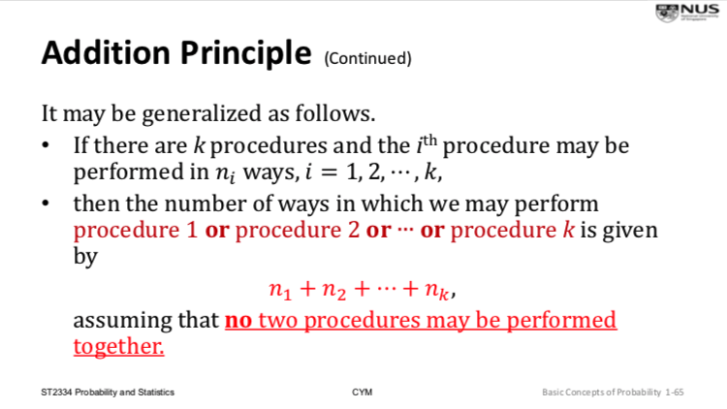

Permutation

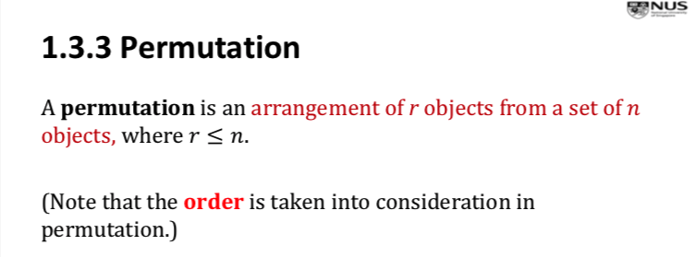

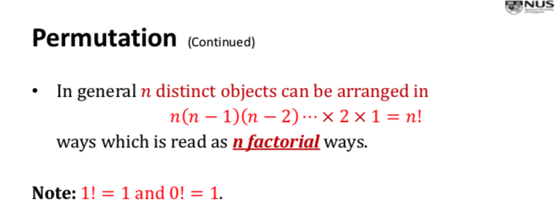

Permutation of n distinct objects taken r at a time

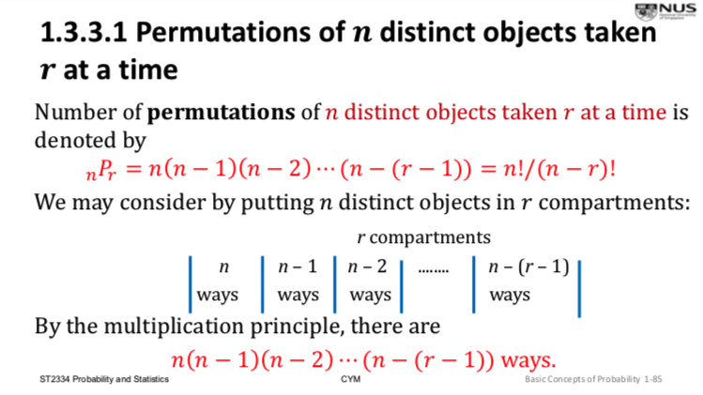

Permutations of n distinct objects arranged in a circle

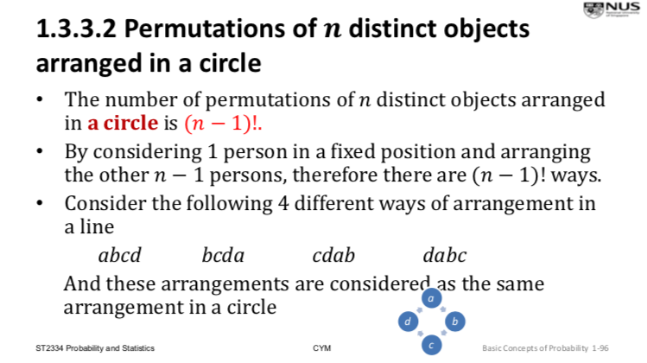

Permutations when not all n objects are distinct

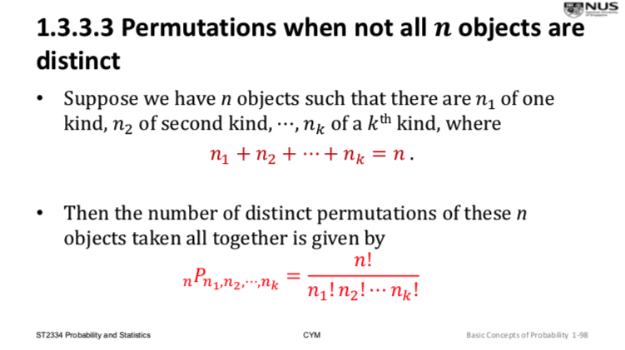

Combination

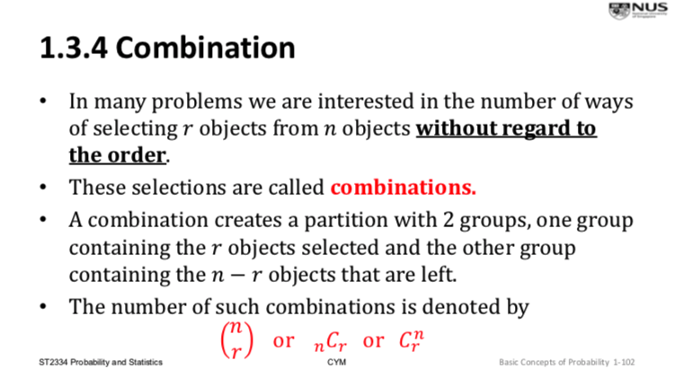

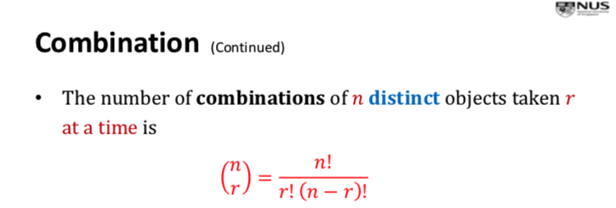

Binomial Coefficient

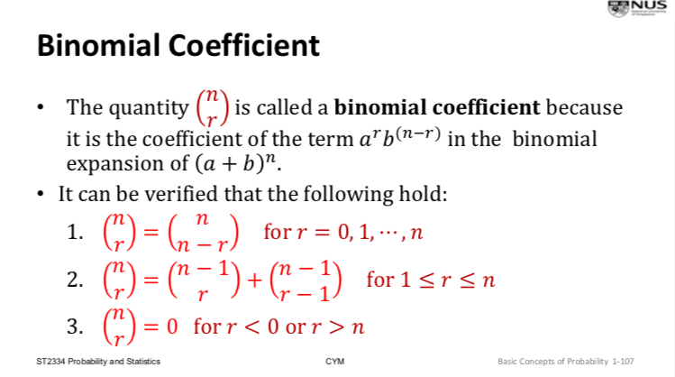

Axioms of Probability/Laws of Probability

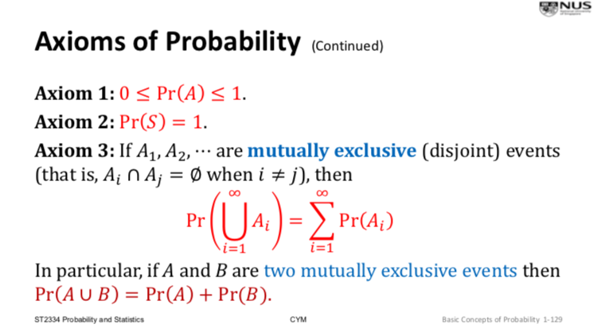

Basic Properties of Probability

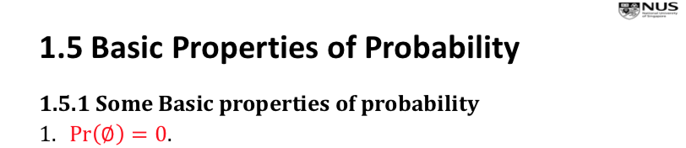

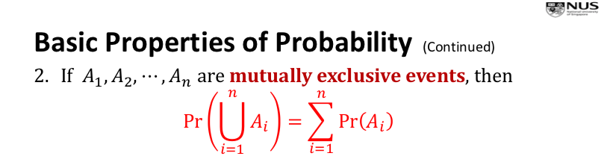

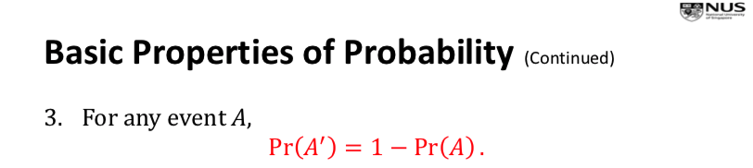



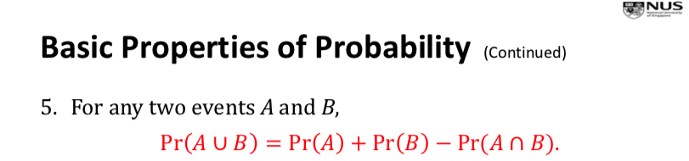

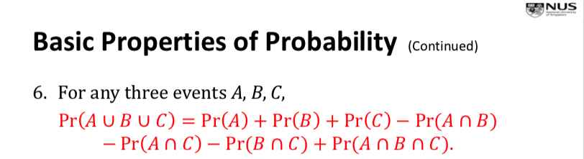

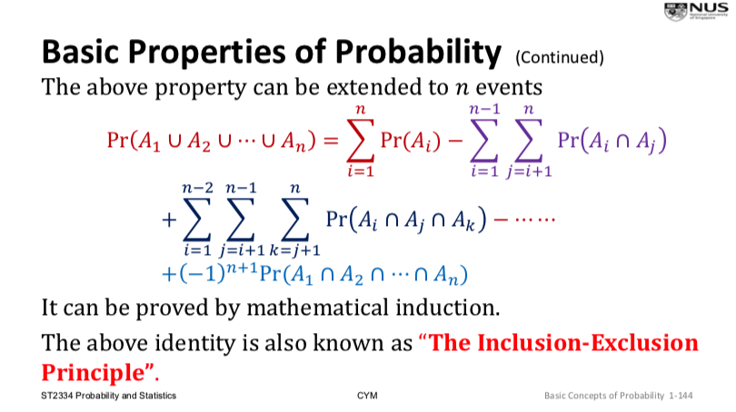



Sample Spaces having Finite Outcomes

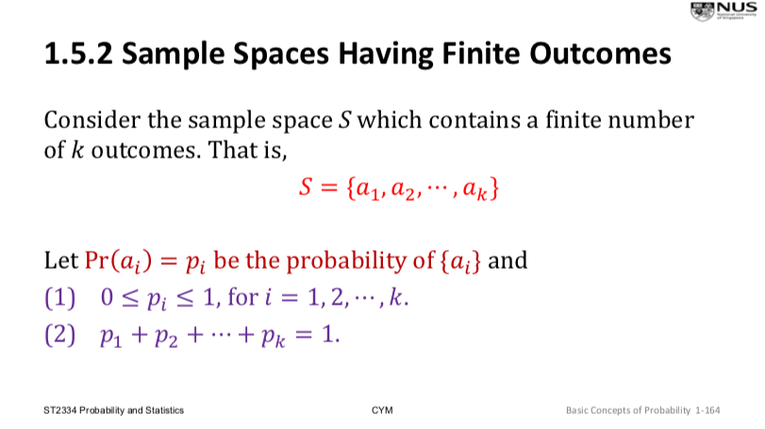

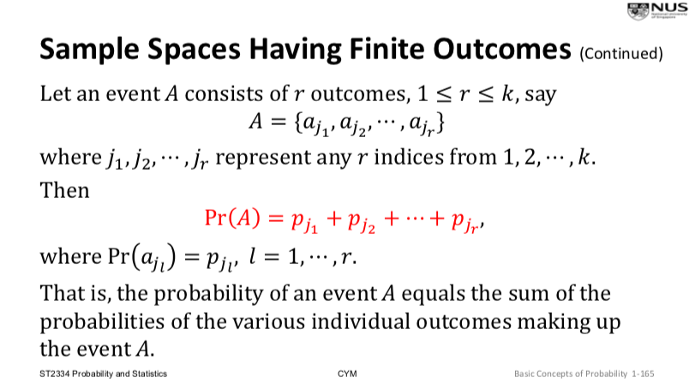

Conditional Probability

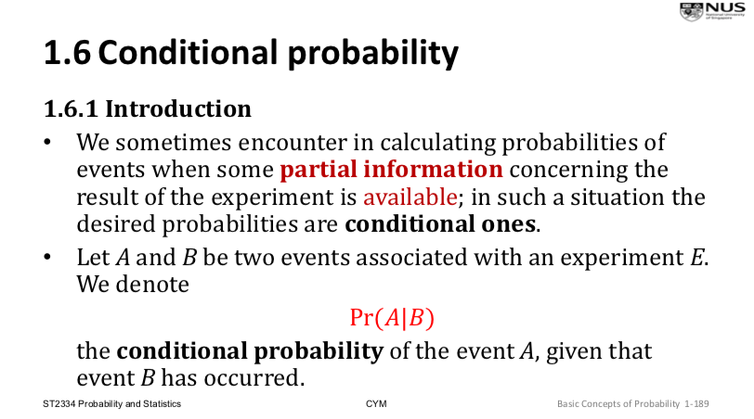

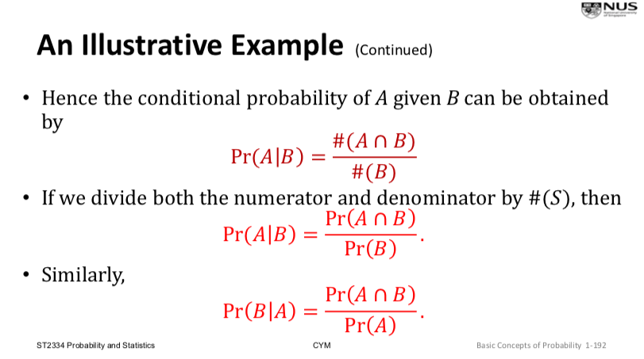

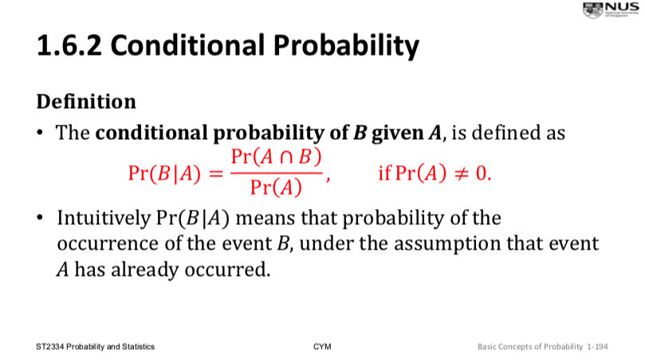

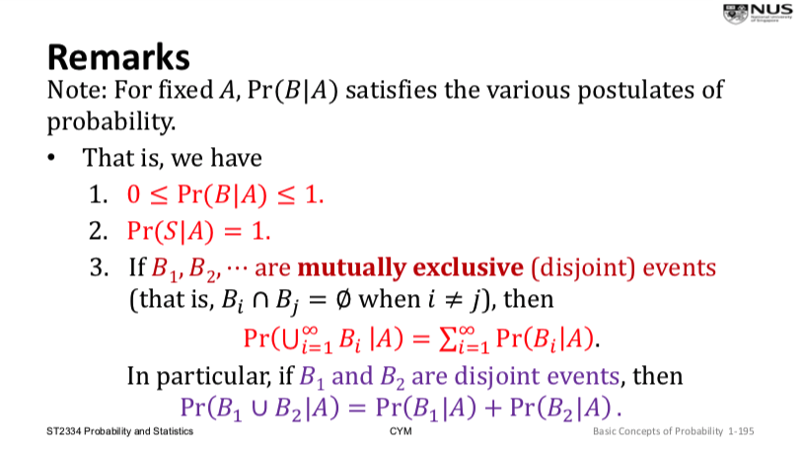

Multiplicative Rule of Probability

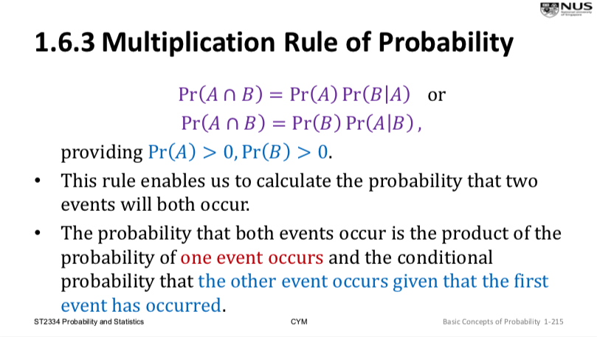

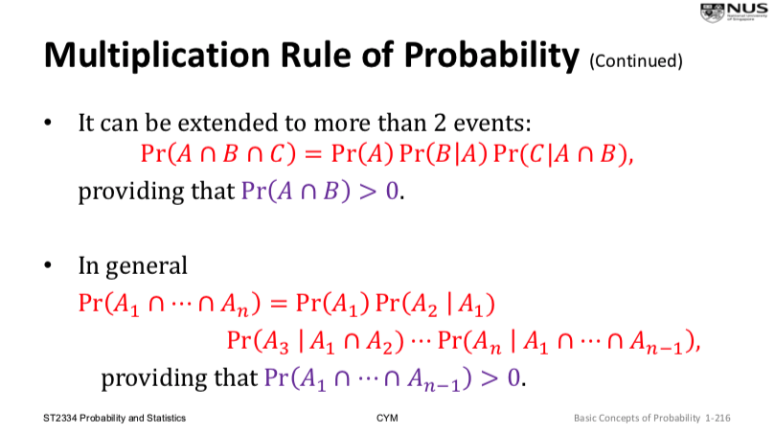

The Law of Total Probability

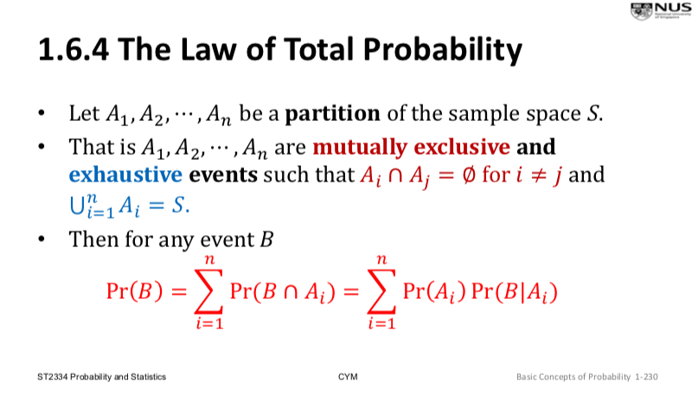

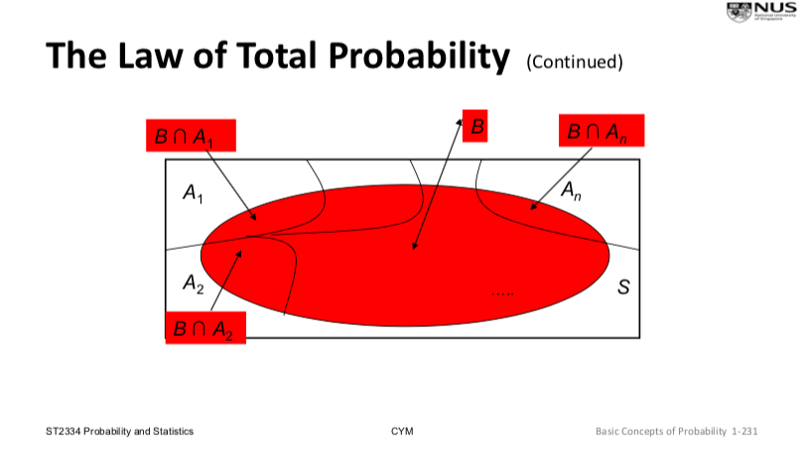

Bayes’ Theorem

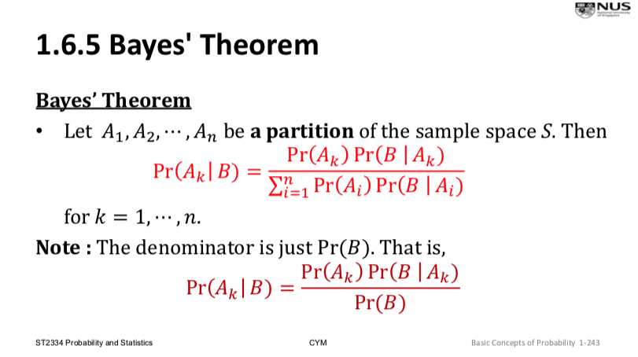

Independent Events

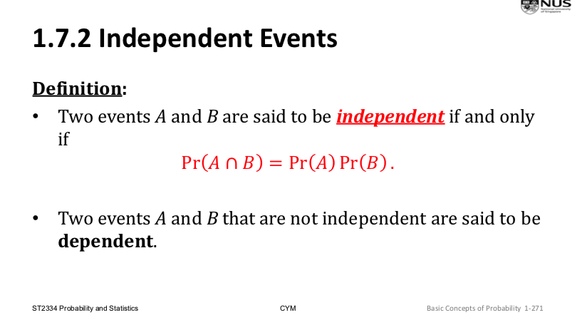

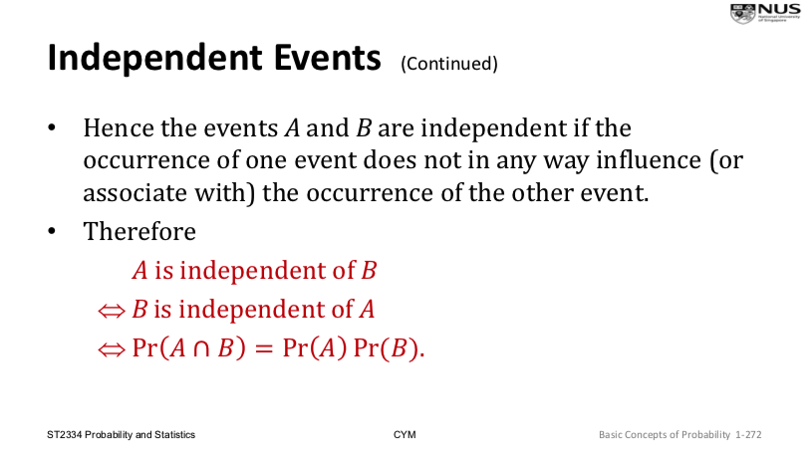

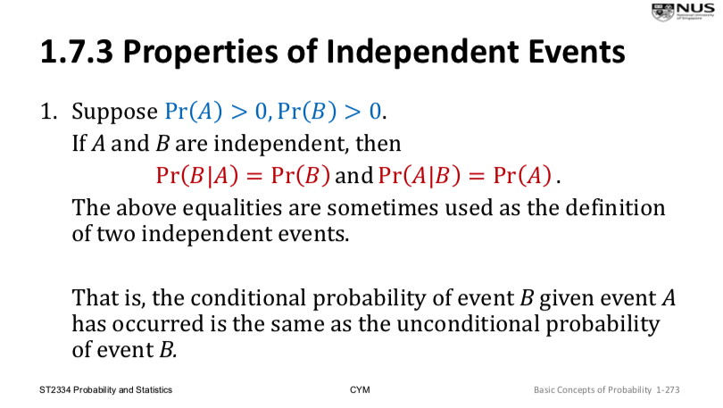

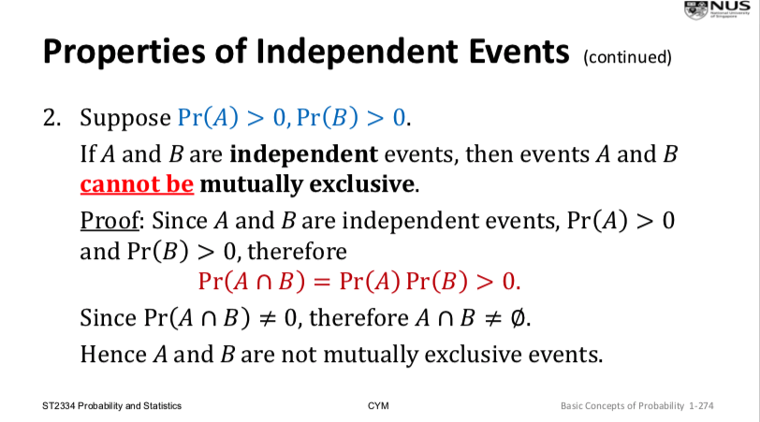

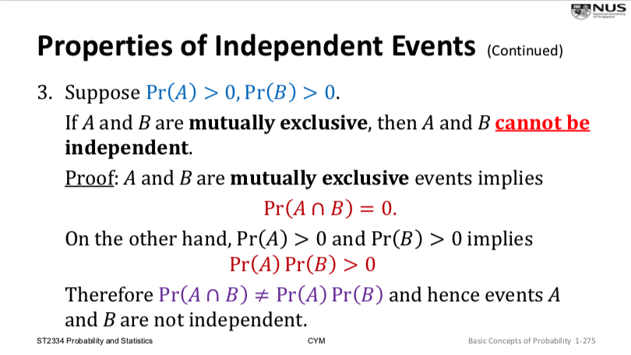

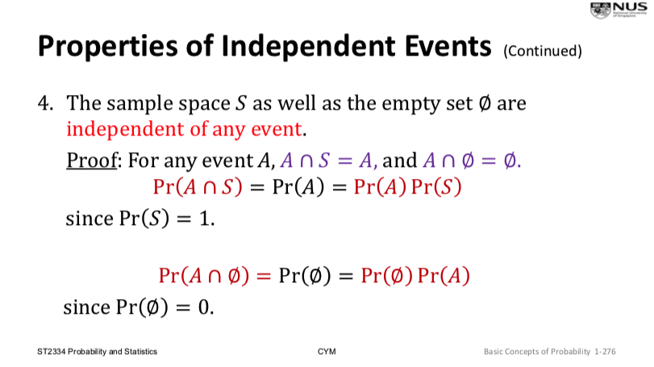

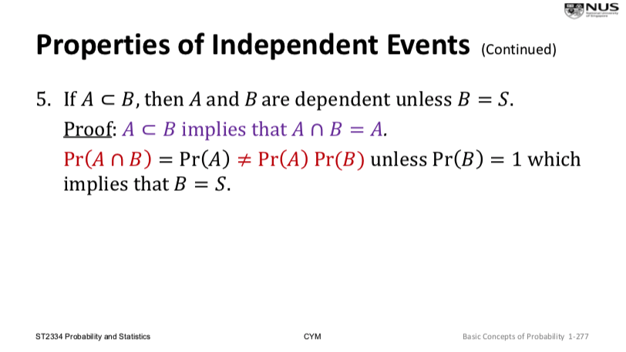

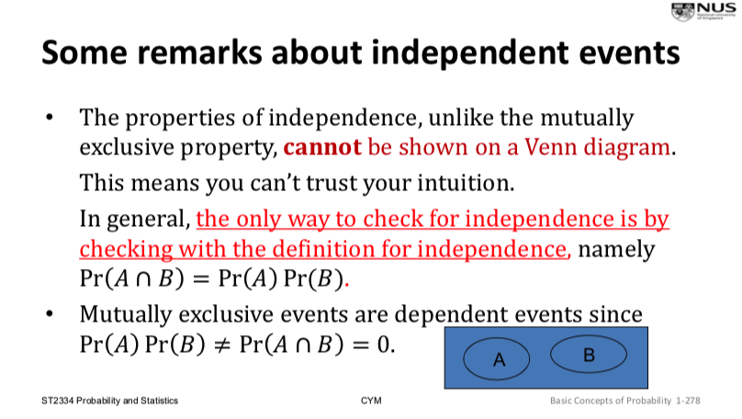

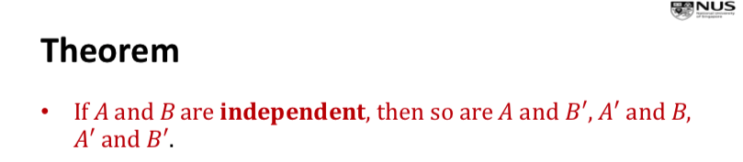

N Independent Events (Pairwise Independent Events)

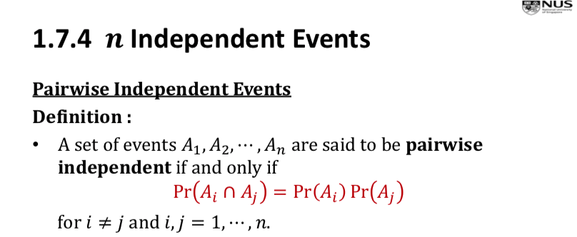

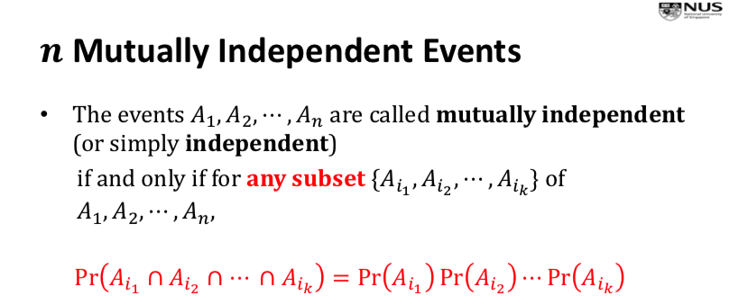

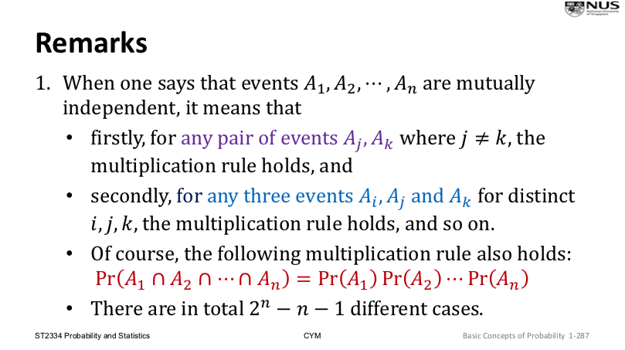

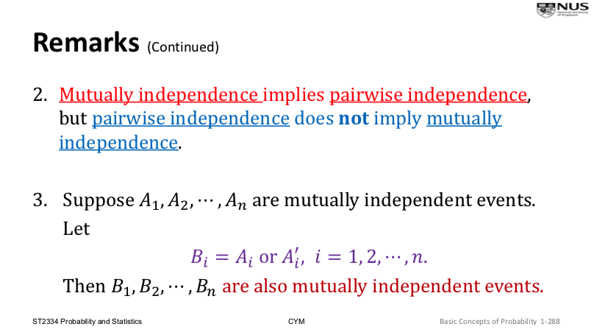

CHAPTER 2: CONCEPTS OF RANDOM VARIABLE

Random Variable

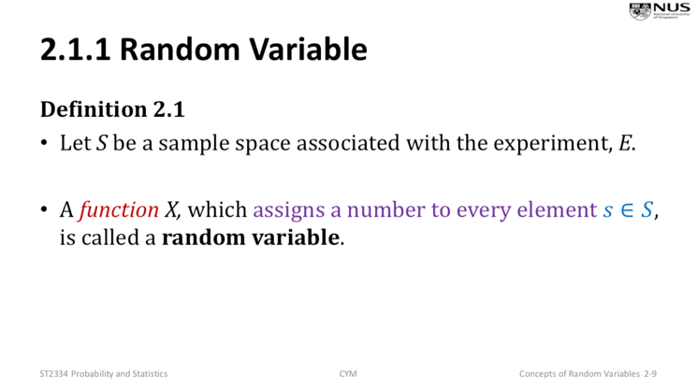

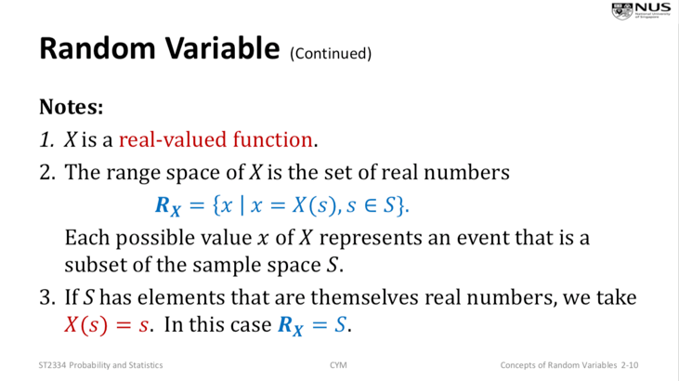

Equivalent Events

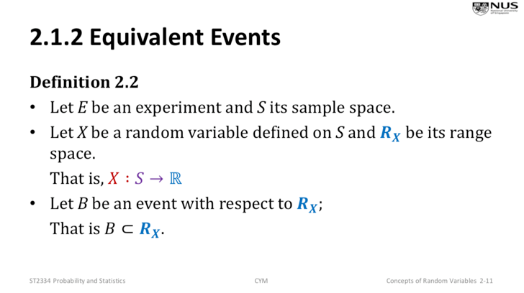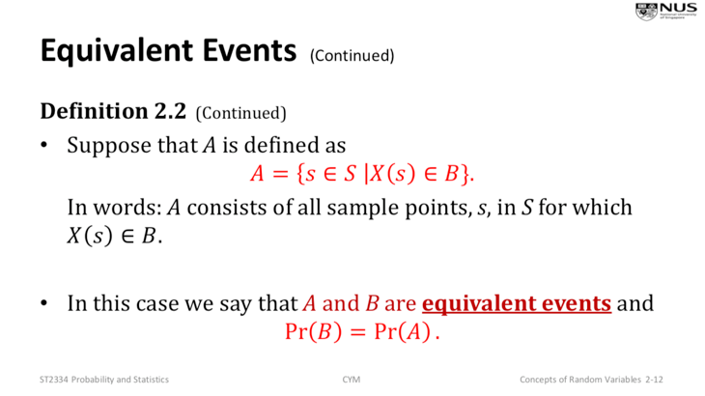

Discrete Random Variable

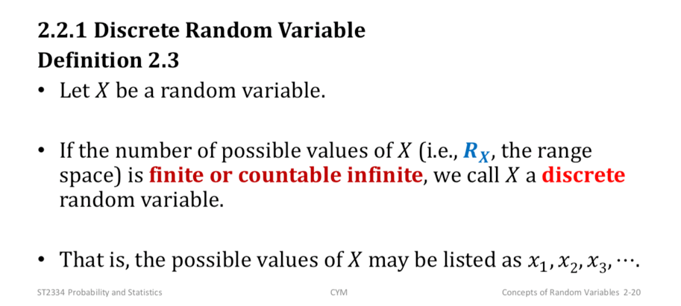

Probability Function

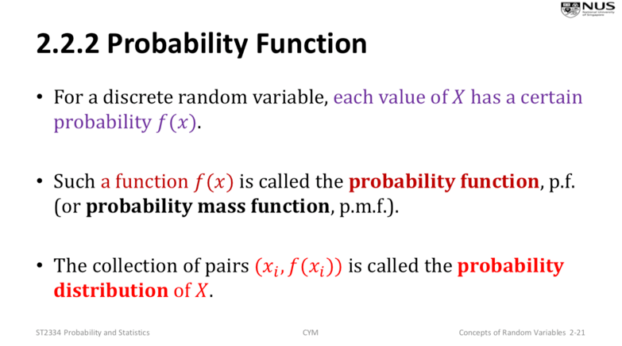

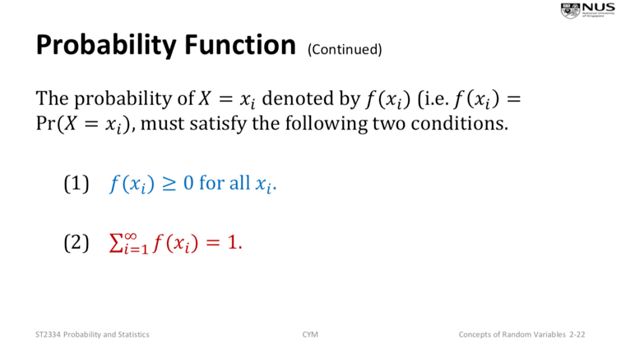

Continuous Random Variable

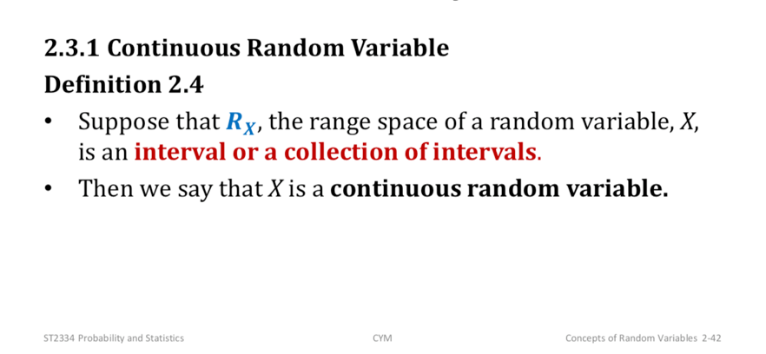

Probability Density Function

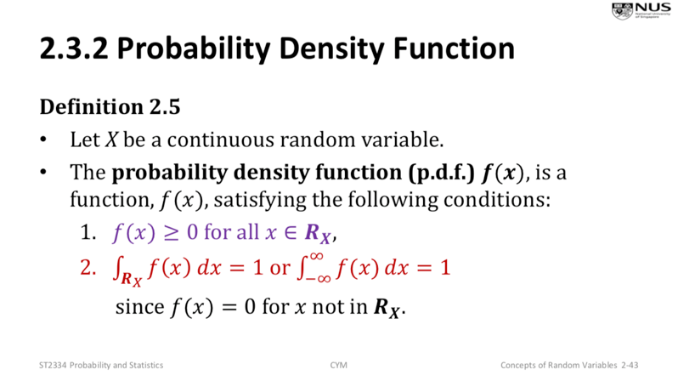

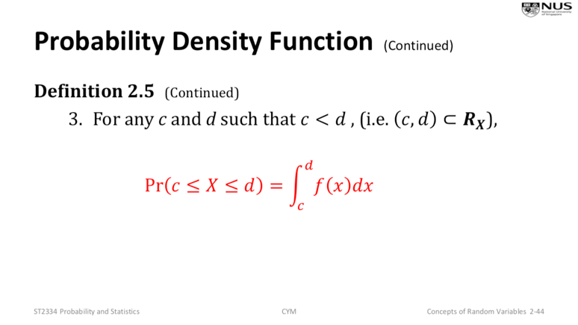

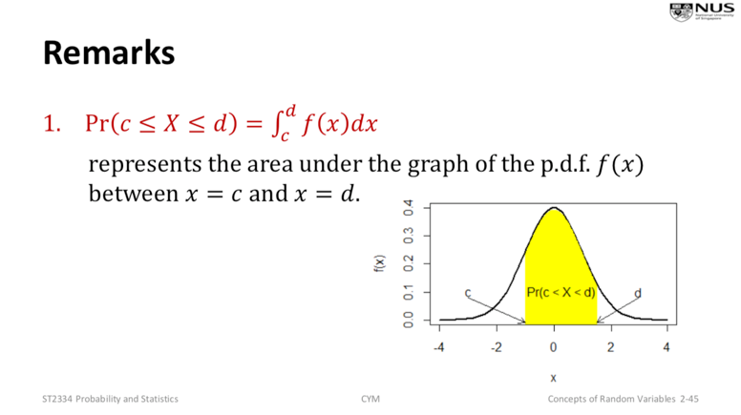

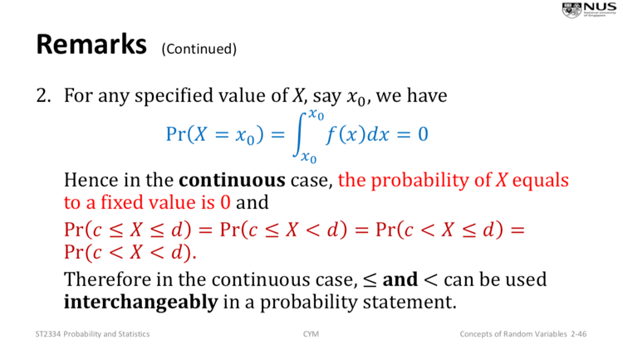

\*If x is continuous, Pr(X <= 5) is the same as Pr(X < 5)

If x is discrete, may not be the same

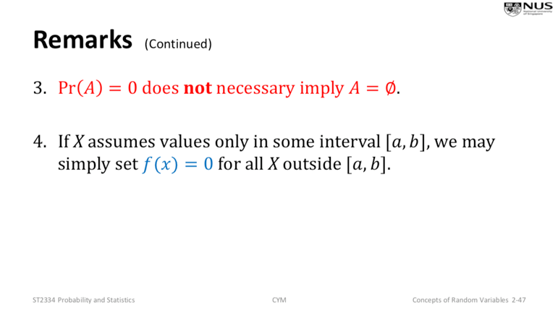

Cumulative Distribution Function

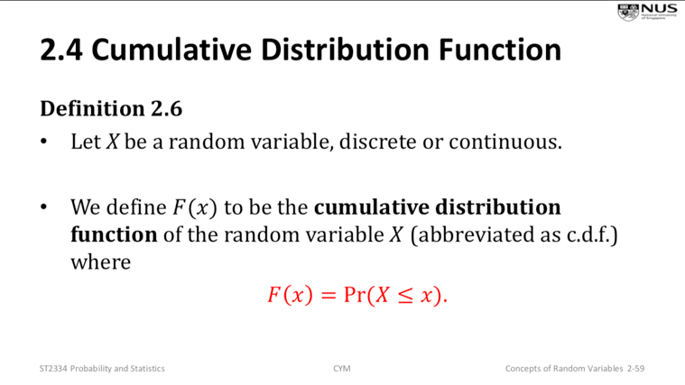

CDF for Discrete Random Variables

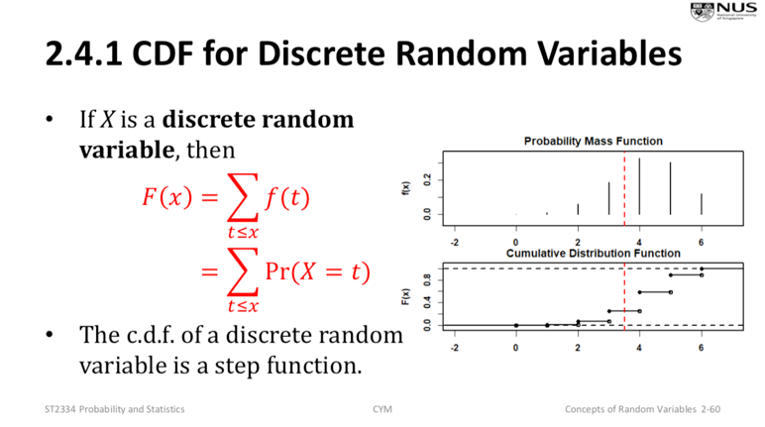

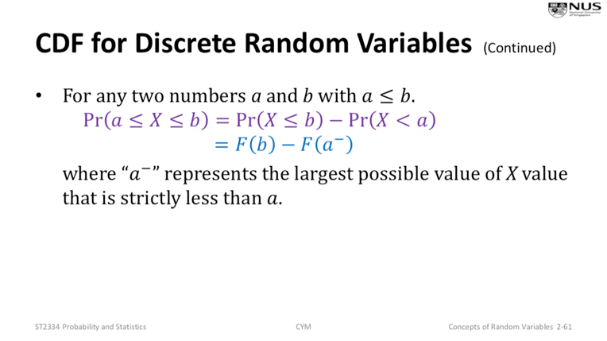

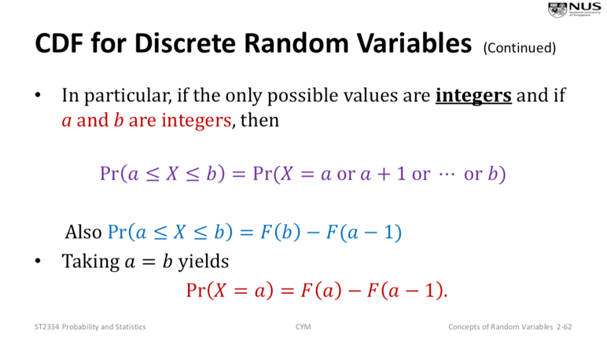

CDF for Continuous Random Variables

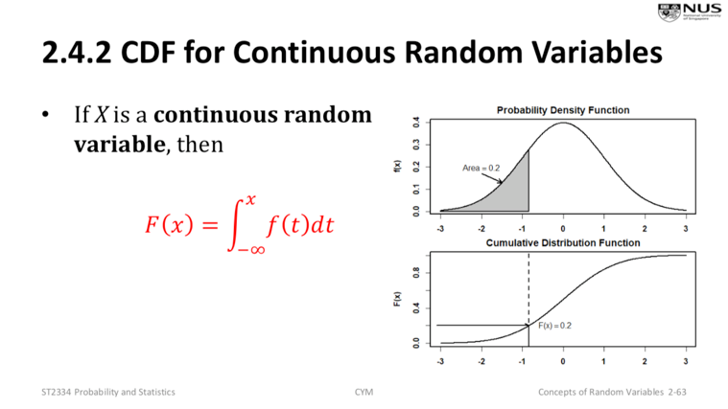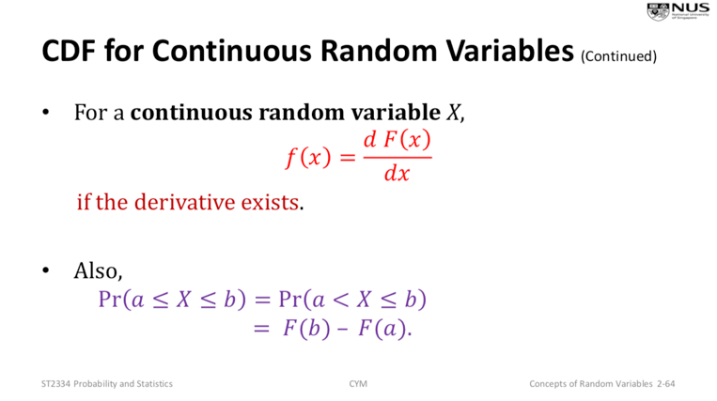

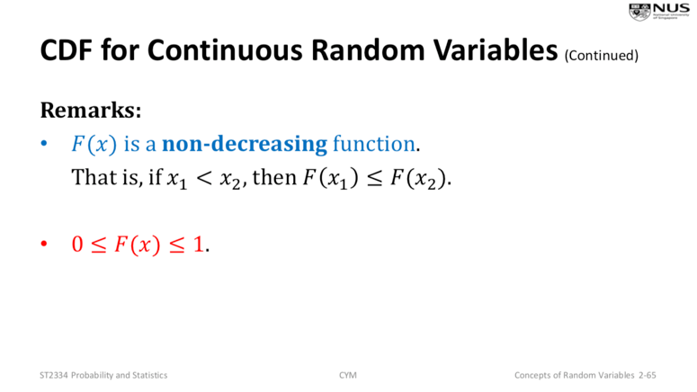

Mean or Expected Values of Discrete Random Variable

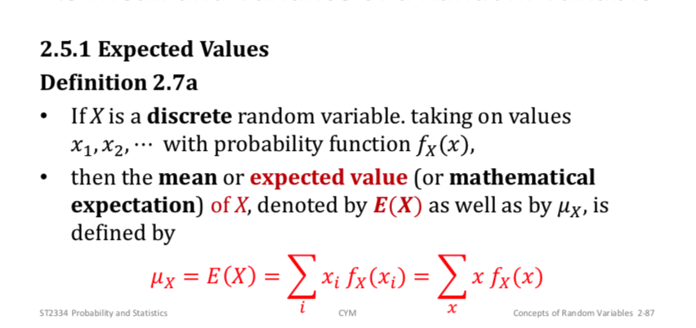

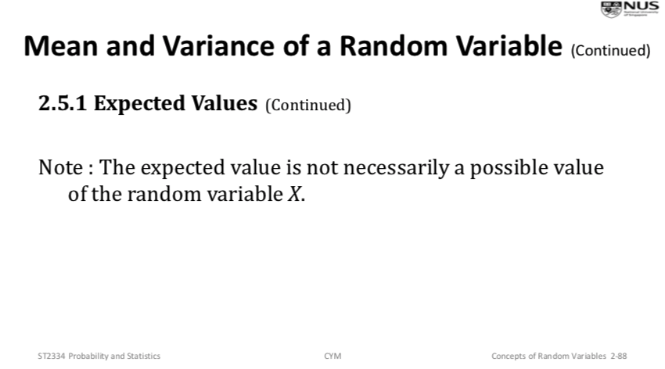

Mean or Expected Values of Continuous Random Variable

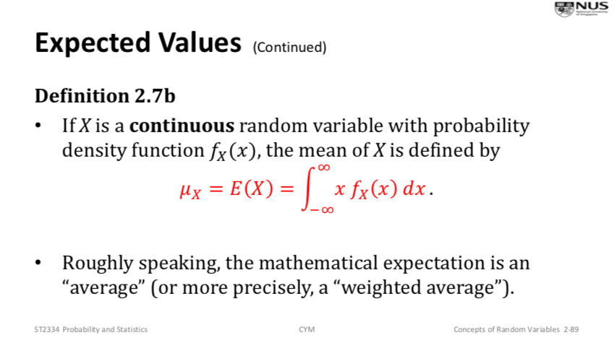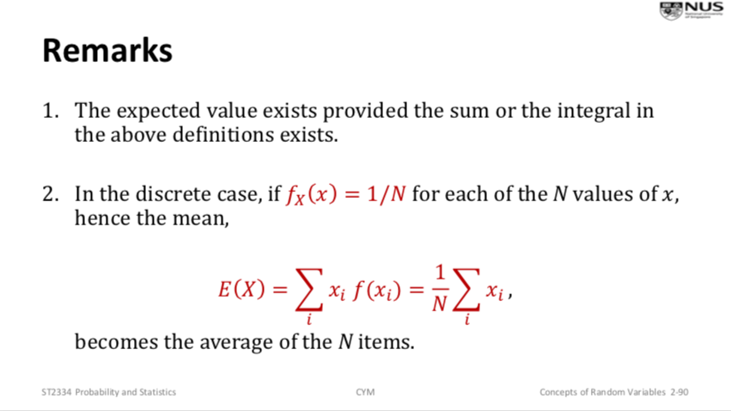

Expectation of a Function of a Random Variable (note: μx is the mean)

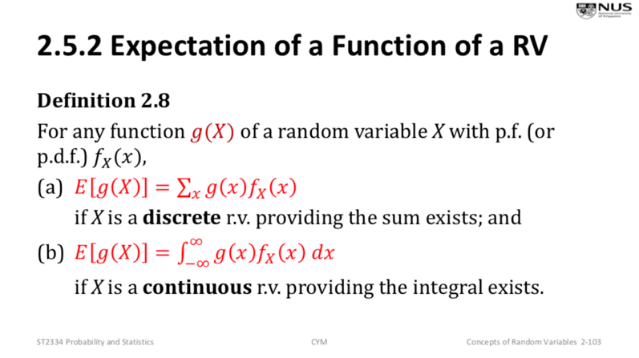

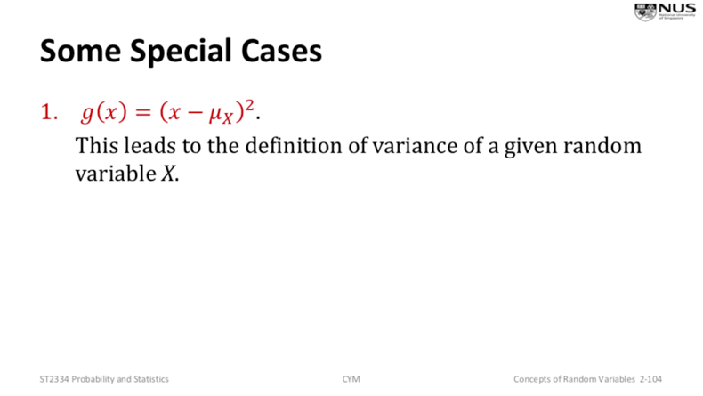

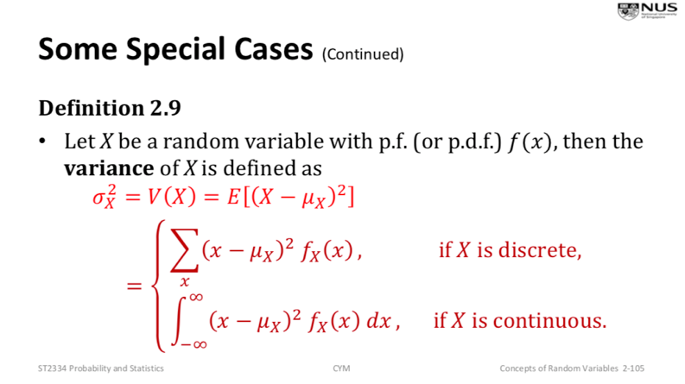

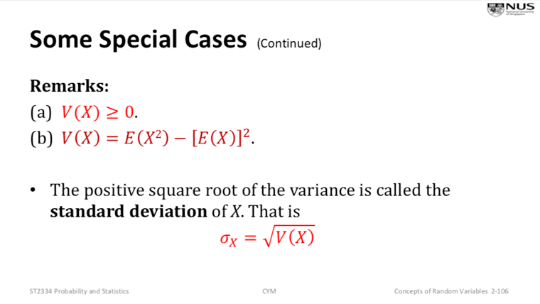

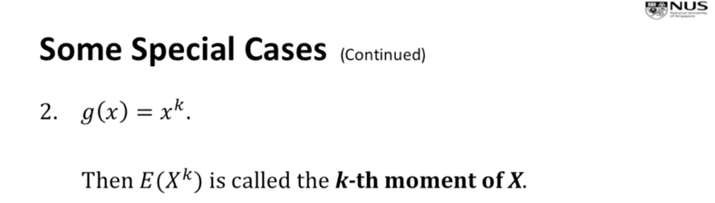

Properties of Expectation

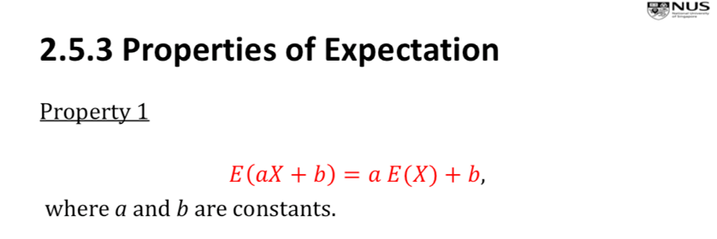

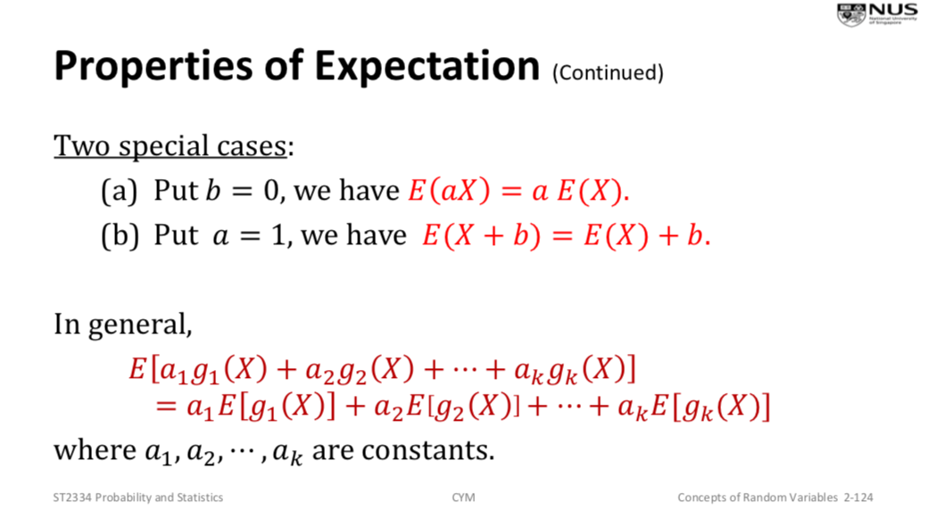





Chebyshev’s Inequality

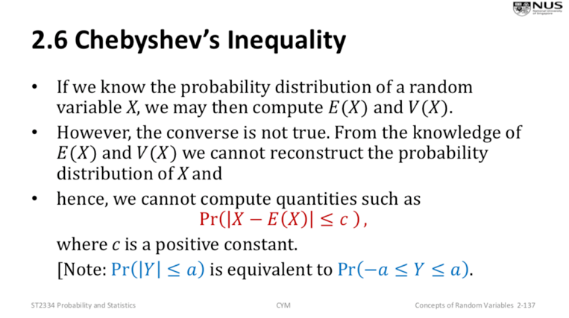

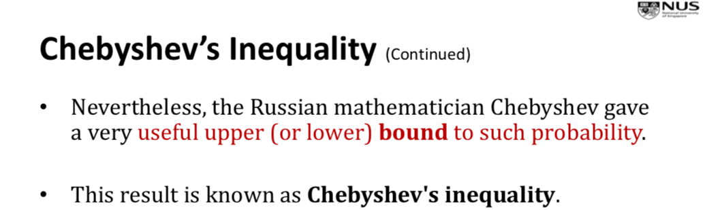

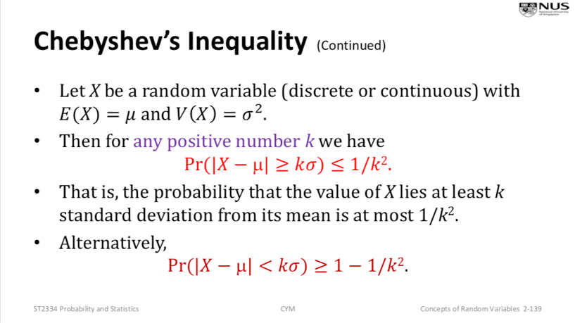

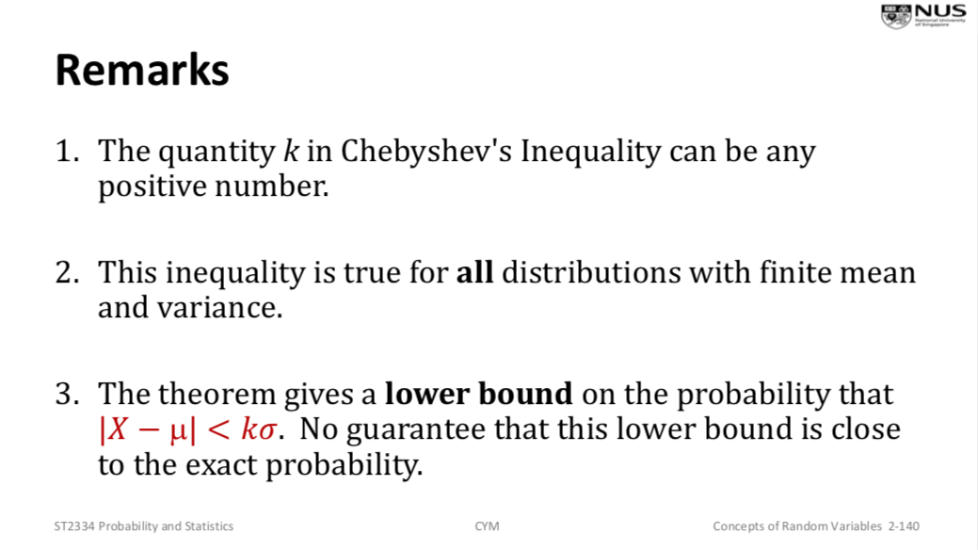

Note: always check that the probability function is well defined

i.e. all probabilities >= 0, all probabilities add up to 1.

CHAPTER 3: 2-D RANDOM VARIABLES AND CONDITIONAL PROBABILITY DISTRIBUTIONS

Two Dimensional Random Variables

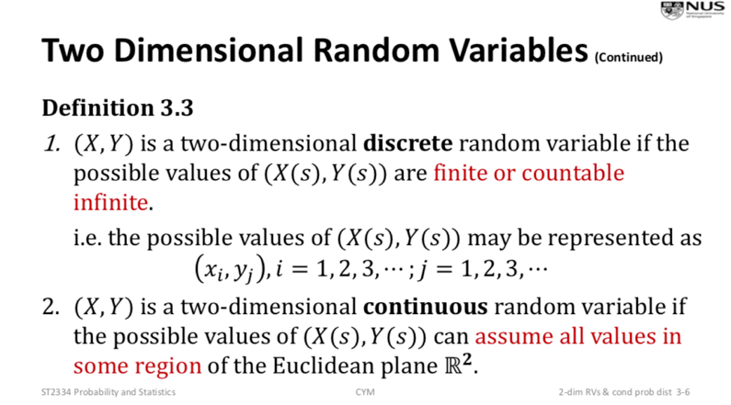

Joint Probability Function for Discrete Random Variables

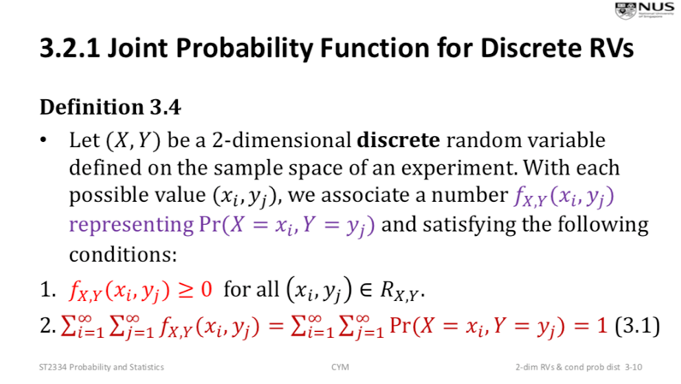

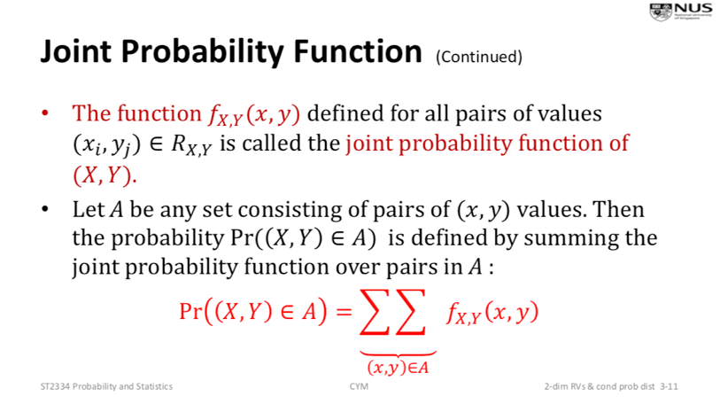

Joint Probability Function (pdf) for Continuous Random Variables

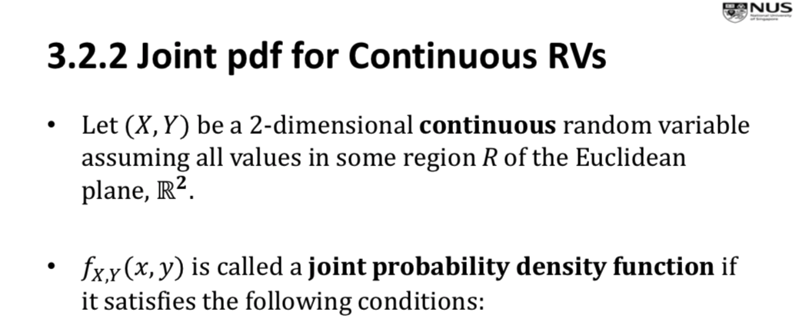

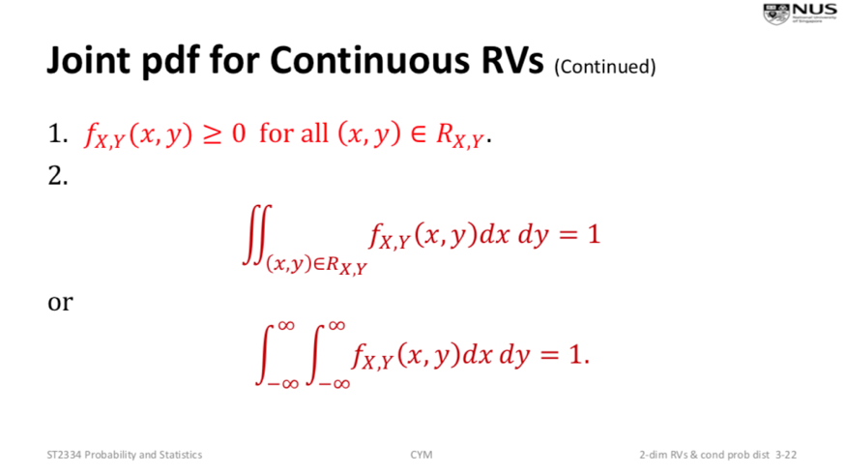

Marginal Probability Distributions

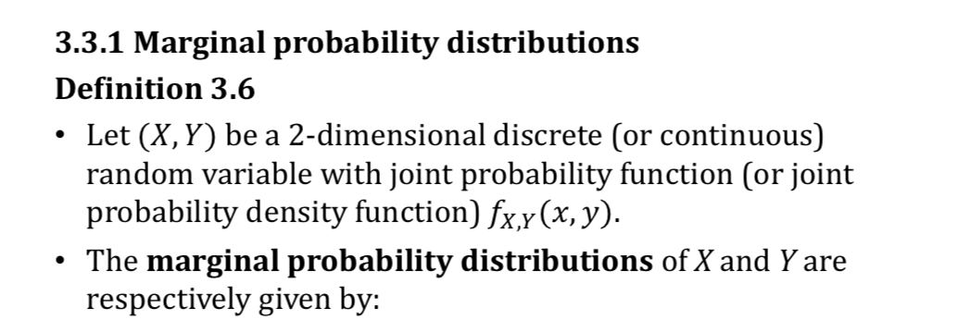

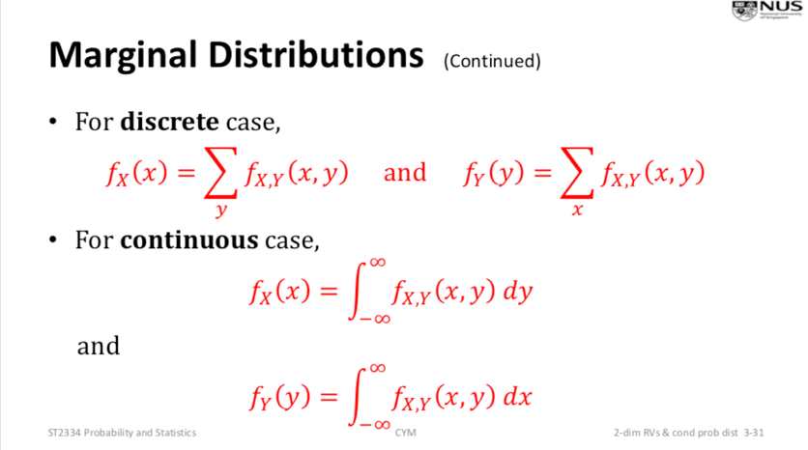

Conditional Distribution

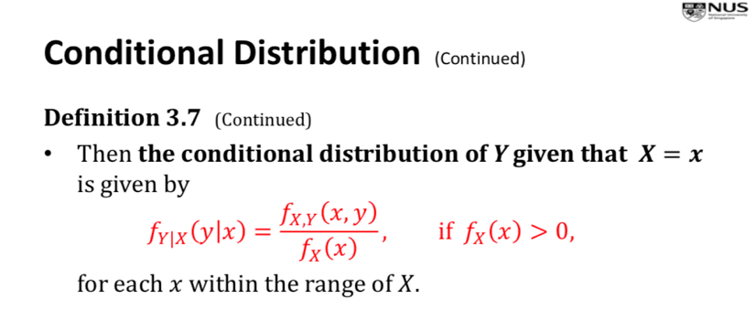

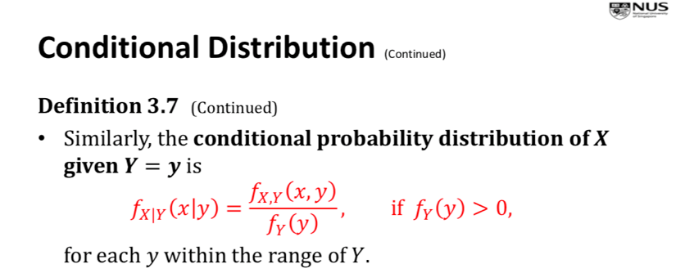

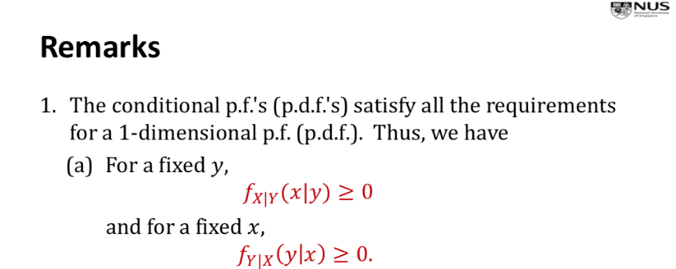

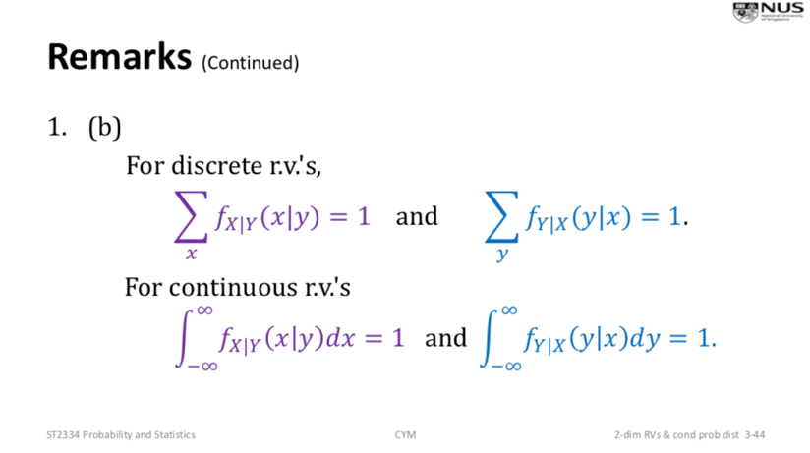

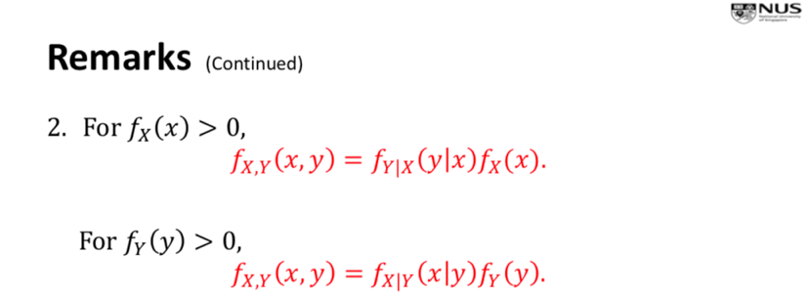

Independent Random Variables

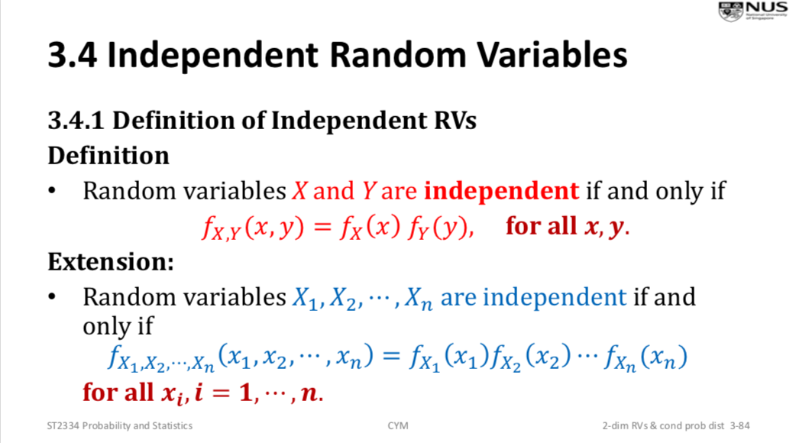

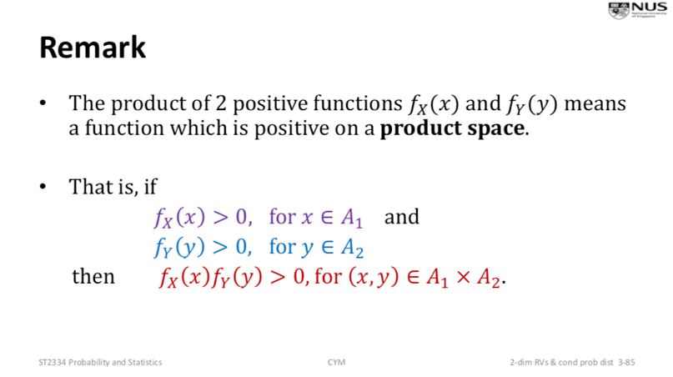

Expectation, covariance of X,Y

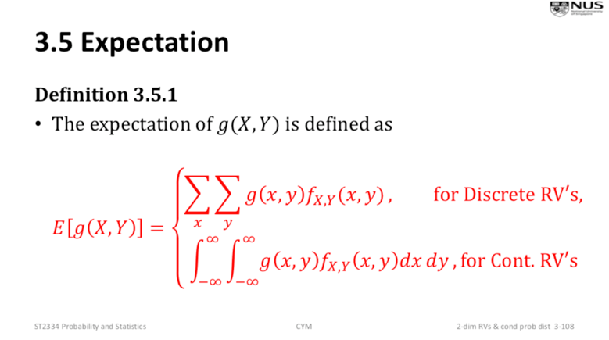You need this for E(XY) to find Cov(X,Y)

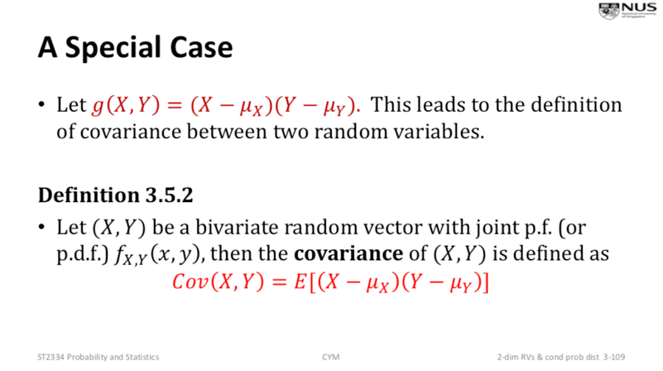

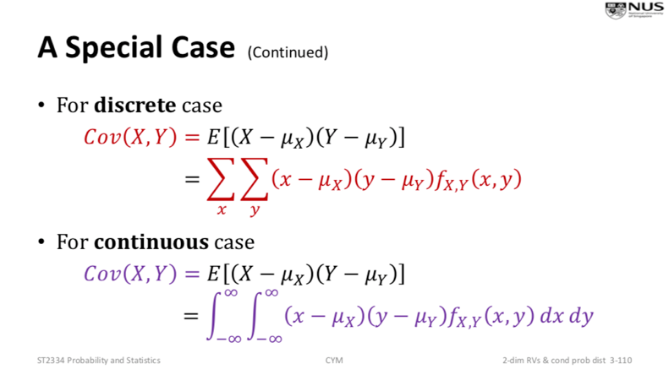

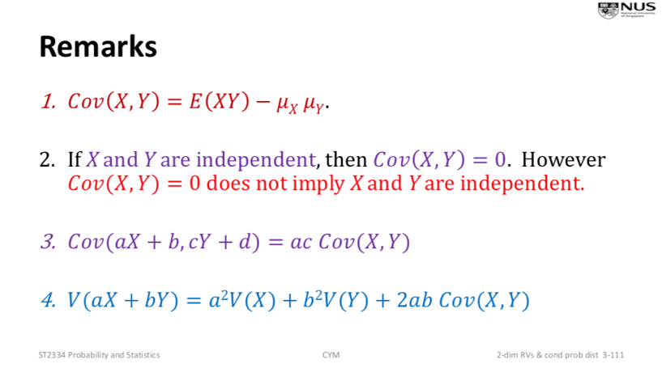variance, covariance, expectation

Correlation Coefficient

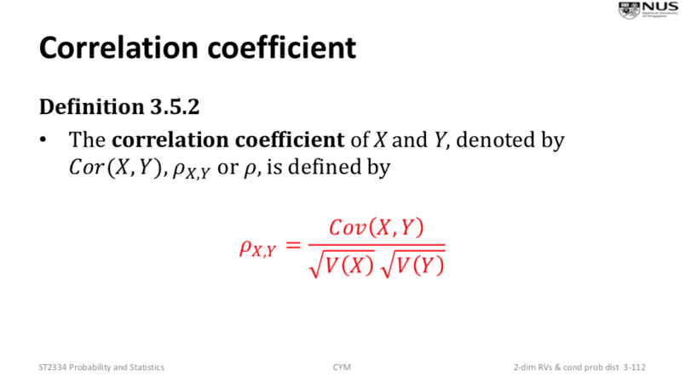

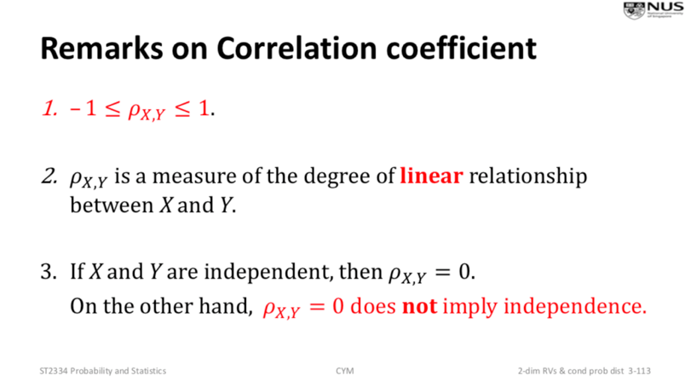

Note: E(Y – X) = E(Y) – E(X)

Note: Cov(X, Y) = E(XY) – E(X)E(Y)

Note: Var(X) = E(X^2) – [E(X)]^2

CHAPTER 4: SPECIAL PROBABILITY DISTRIBUTIONS

Discrete Uniform Distribution (Discrete distribution)

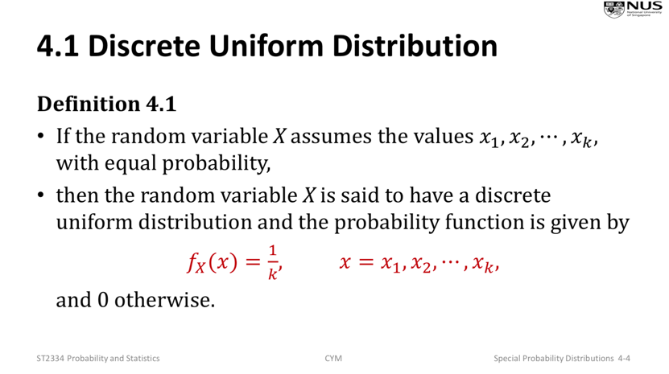

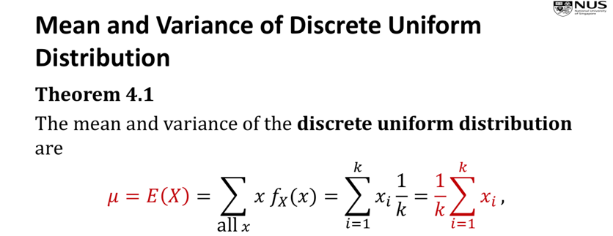

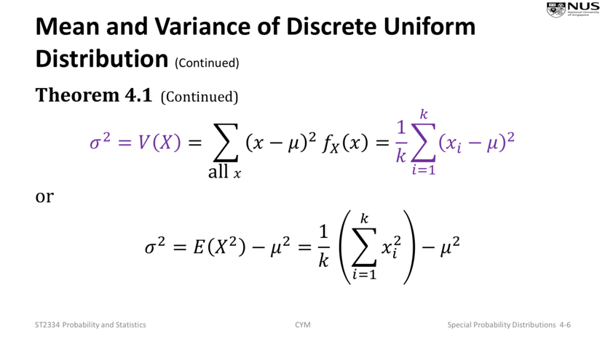

Bernoulli Distribution (Discrete distribution) – Only two possible outcomes

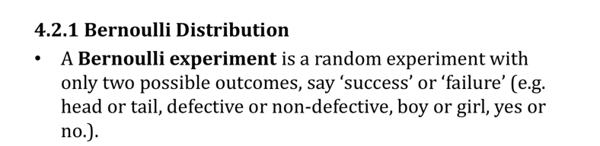

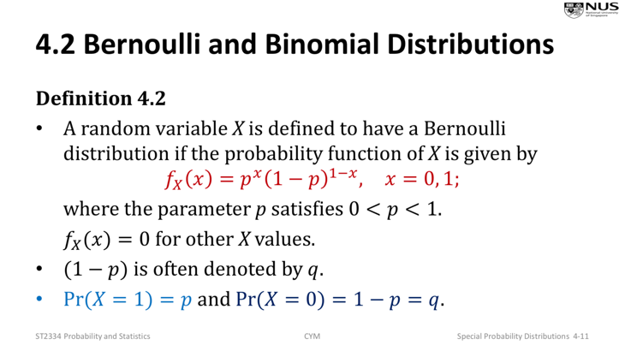

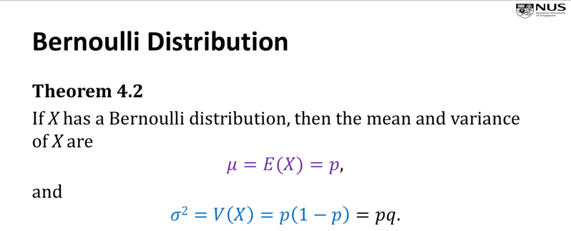

Binomial Distribution (Discrete distribution) – Bernoulli but repeated n

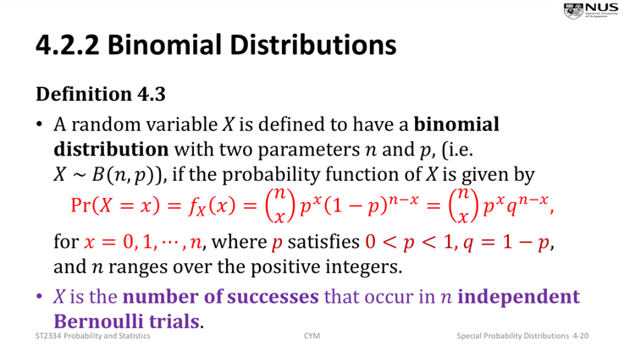

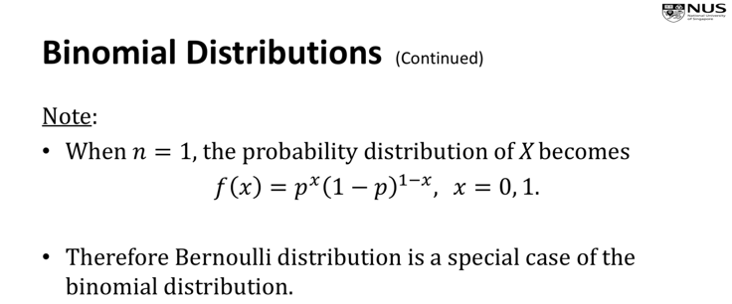

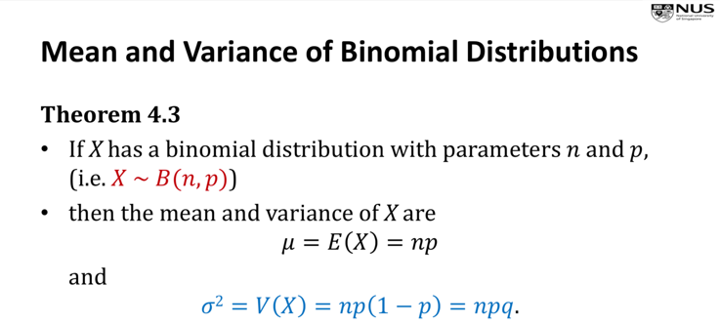

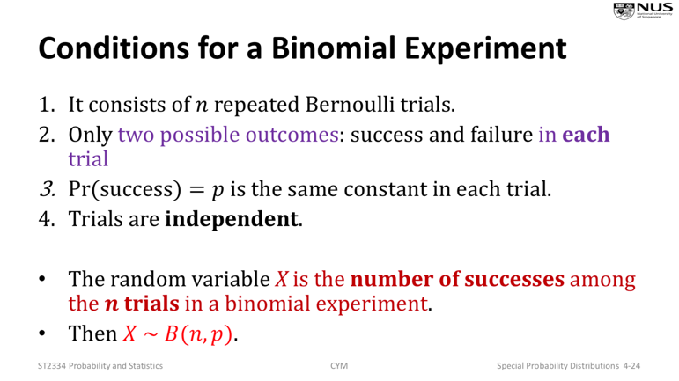

Note: Pr(X = x) = nCx \* p^x \* (1-p)^(n-x)

Note: Pr(X >= 8) = 1 – Pr(X <= 7)

Negative Binomial Distribution (Binomial, but repeated until a fixed no. of success occur)

Note: The last trial must be a success

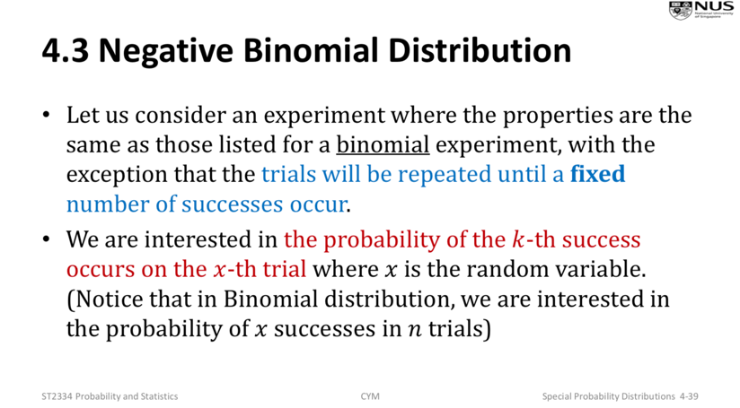

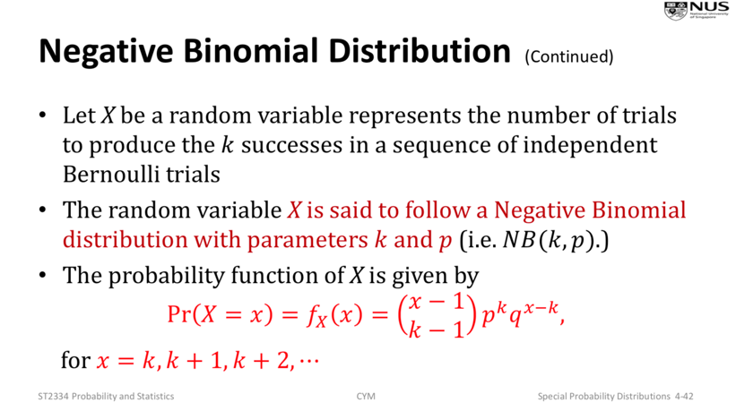

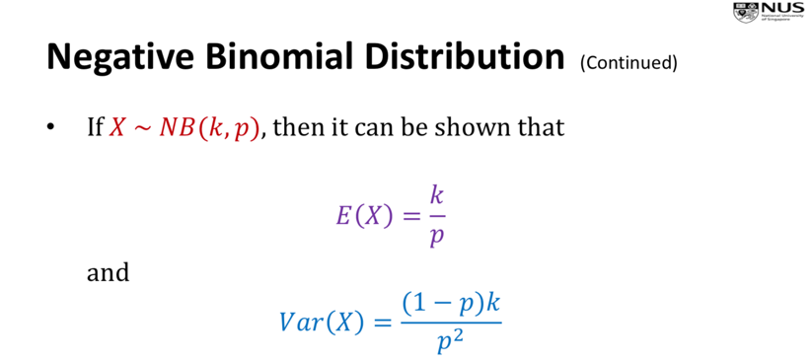

Note: k is the number of successes to produce, p is the probability of success

Poisson Distribution (Discrete distribution) – no. of successes occurring during time interval

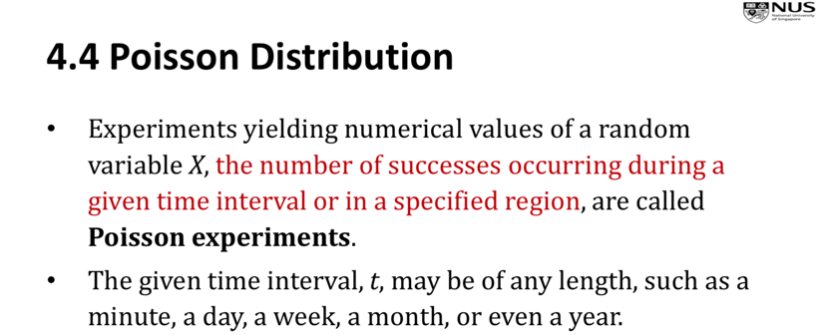

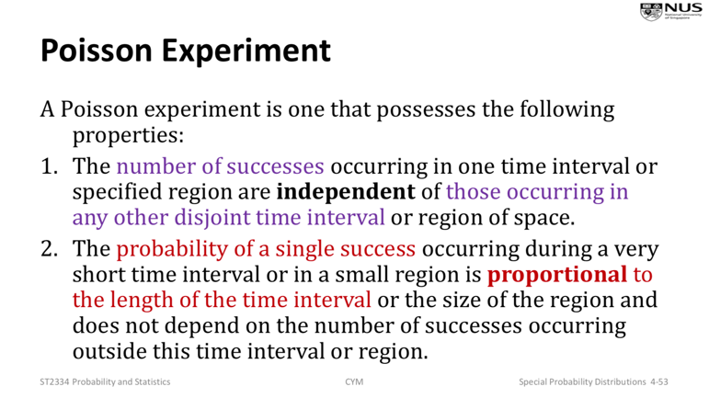

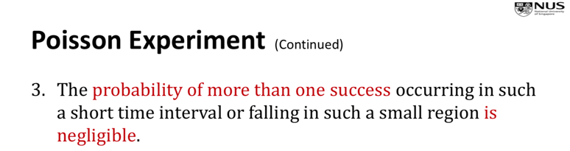

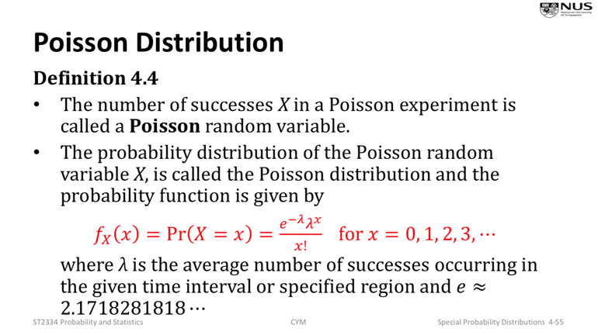

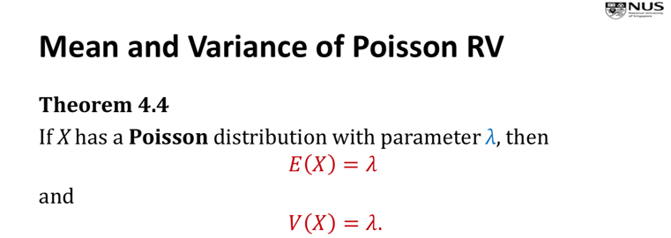

Note: λ = average number of successes in given time period

Eg. Average number of robberies in a day is 4.

To find probability of six robberies occurring in two days, Pr(X=6), where X~P(2\*4=8)

If want to find probability of X in n time periods, first find the probability of X in one time period, then a new variable Y will follow the binomial distribution with p = the probability

Poisson Approximation to Binomial Distribution

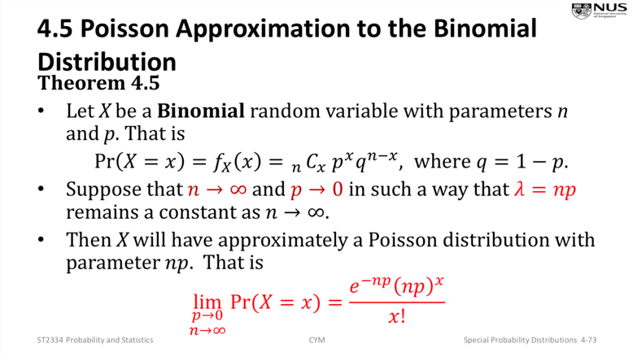

Continuous Uniform Random Variable (Continuous variable)

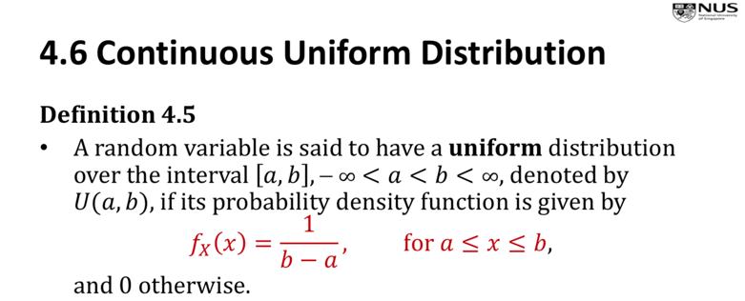

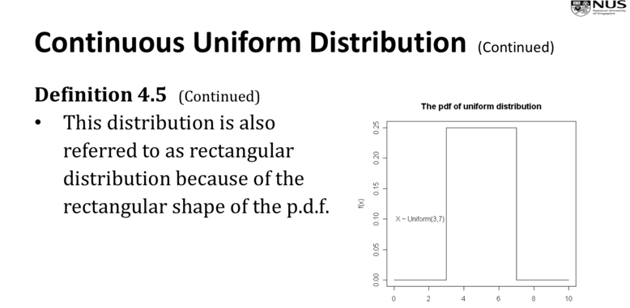

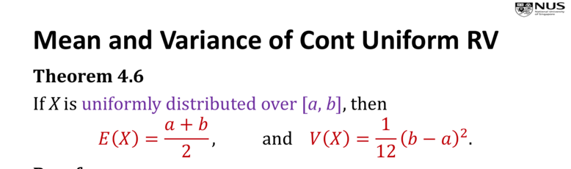

Eg. X~U(0, 2)

Then, fx(X) = ½ for 0 <= x <= 2

Pr(1 <= X <= 3/2) = Int(1/2 dx) from 1 to 3/2

Exponential Distribution (Continuous variable)

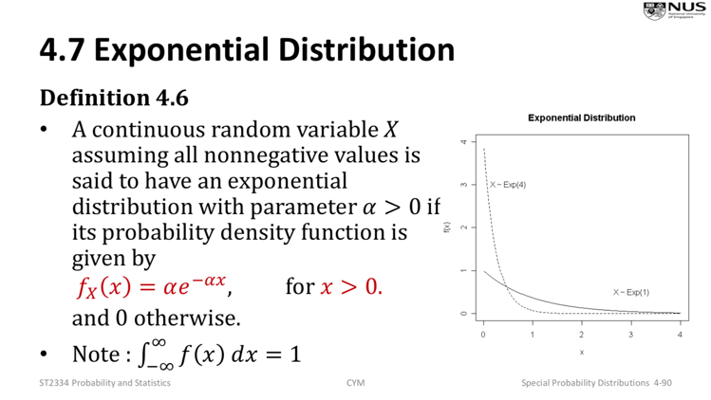

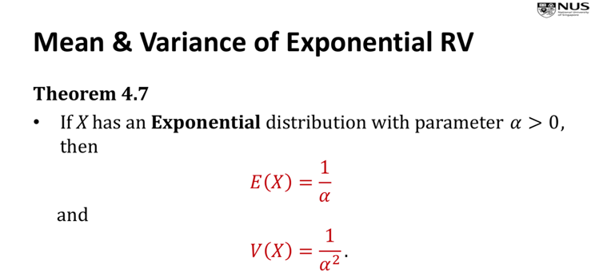 i.e. a = 1/E(X), i.e. X ~ Exp(1/E(X))

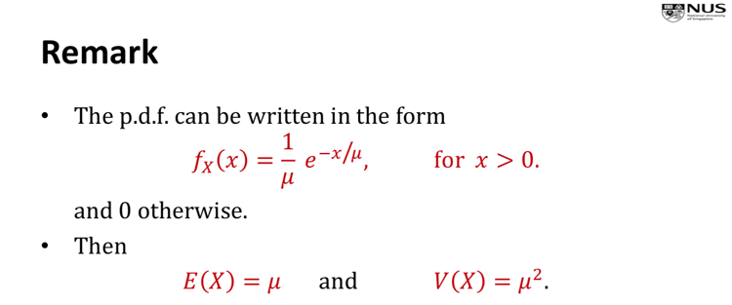

No Memory Property of Exponential Distribution

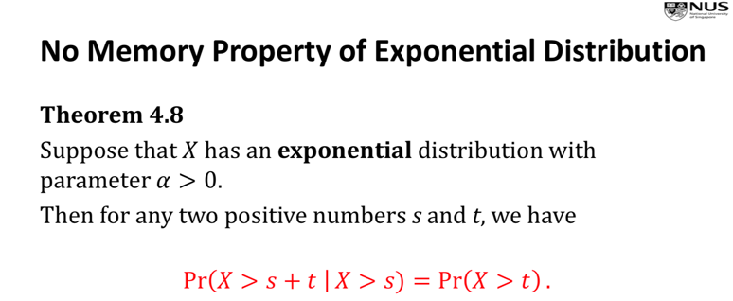

for t > 0

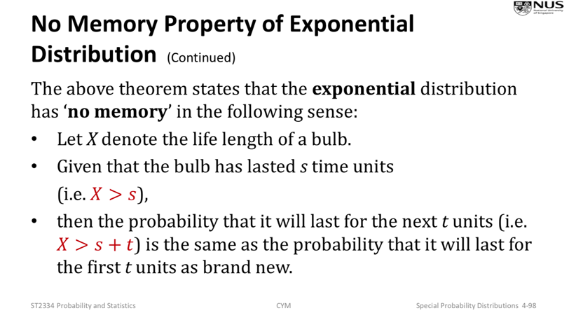

Normal Distribution (Continuous variable)

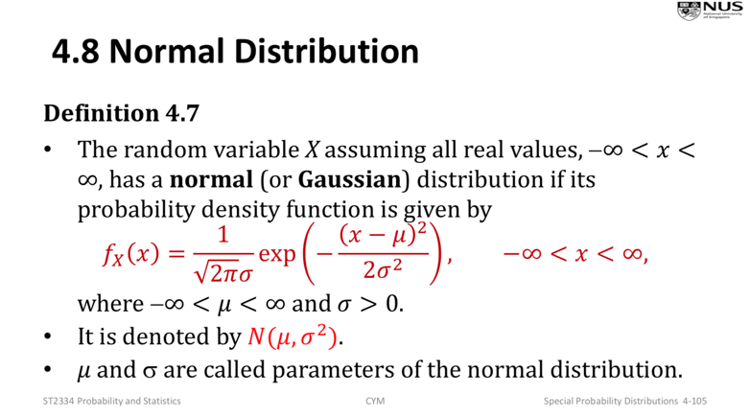

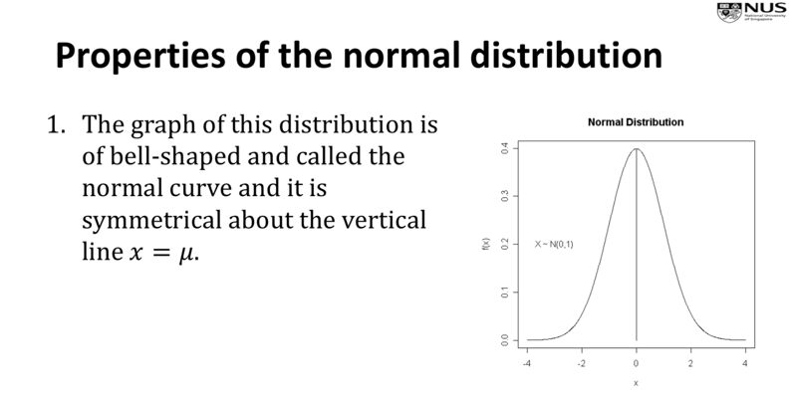

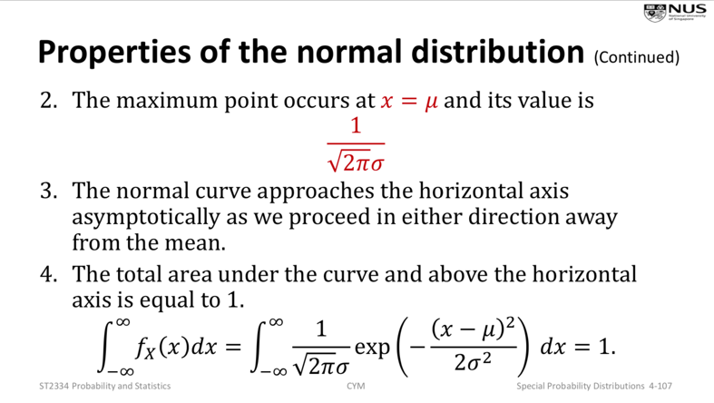

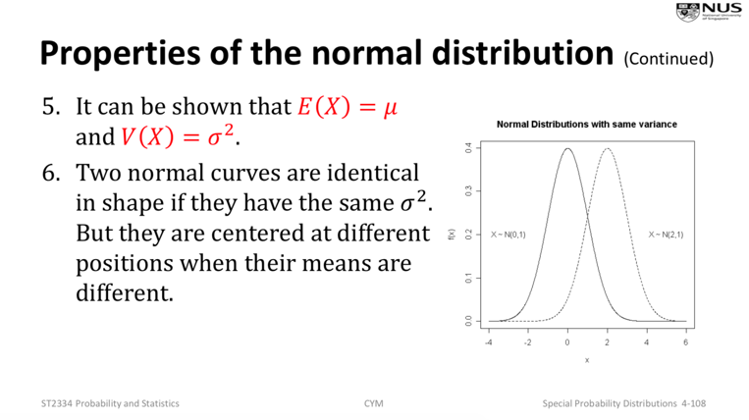

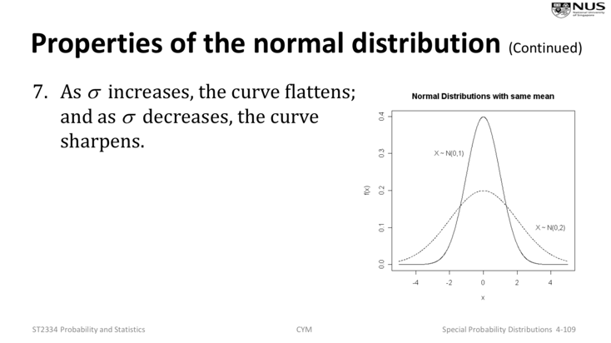

Standardization of Normal Distribution

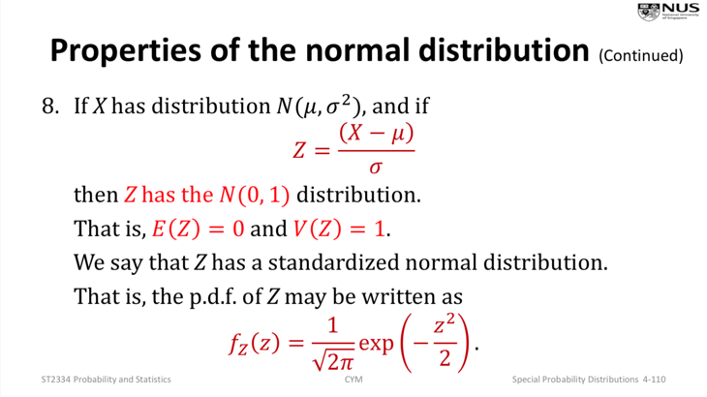NOTE:ALWAYS STANDARDIZE IT

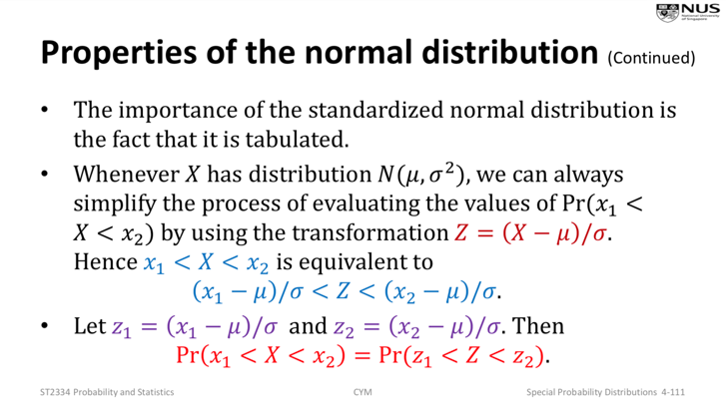

Linear Interpolation (to get z-value from probability in table)

<https://www.johndcook.com/interpolator.html>

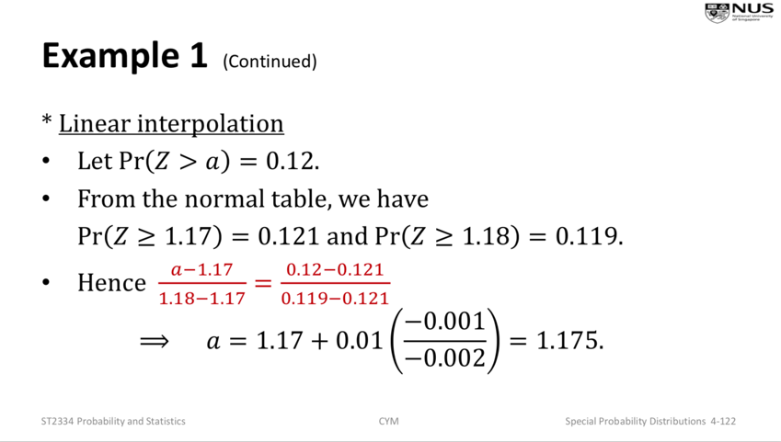

Normal Approximation to Binomial Distribution

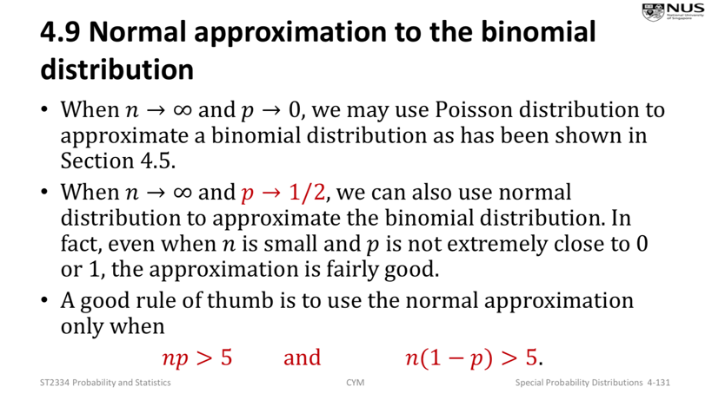

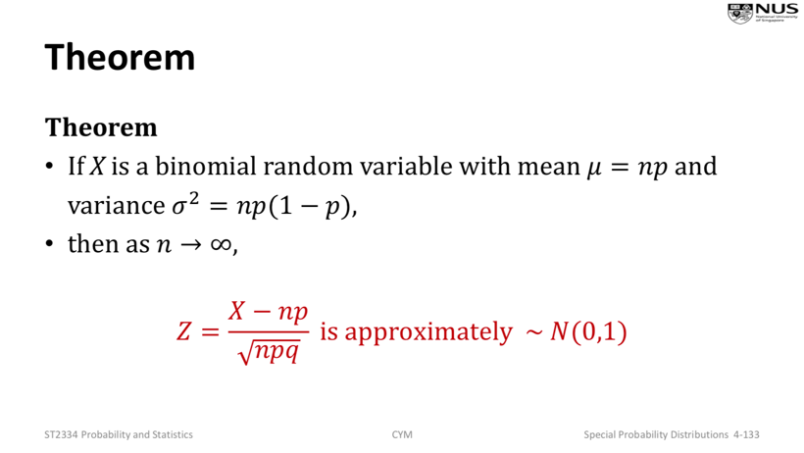

CHAPTER 5: SAMPLING & SAMPLING DISTRIBUTIONS

Simple Random Sample

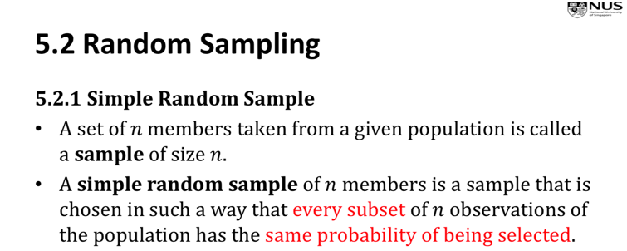

Sampling from Finite population Without replacement

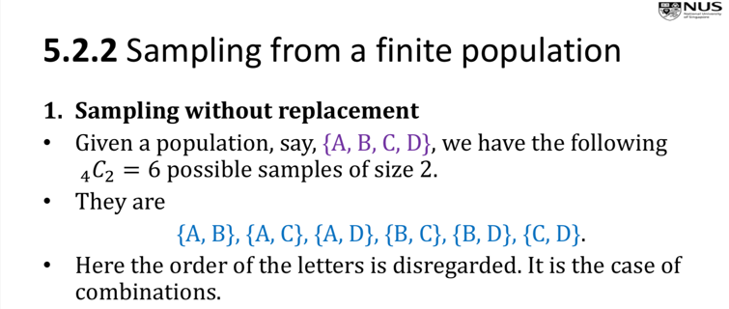

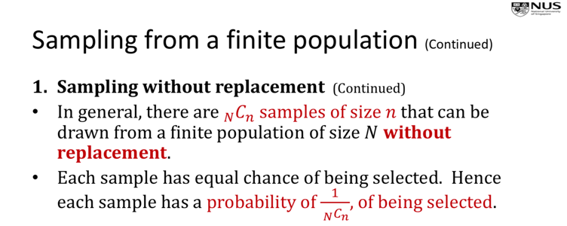

Sampling from Finite population With replacement

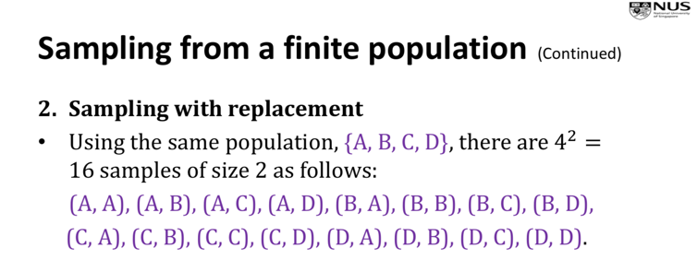

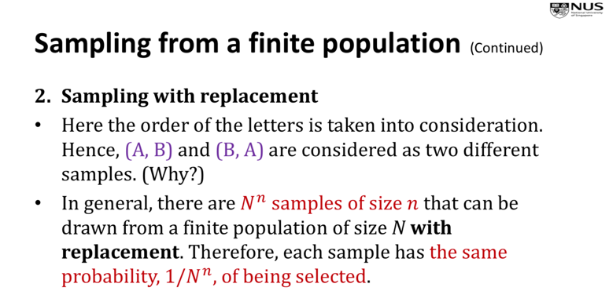

Sampling from infinite population

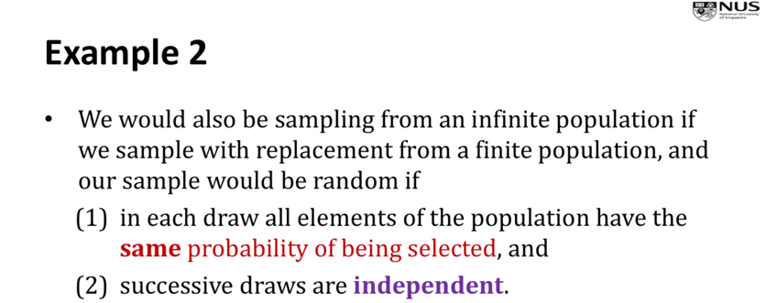

Sampling Distribution of Sample Mean

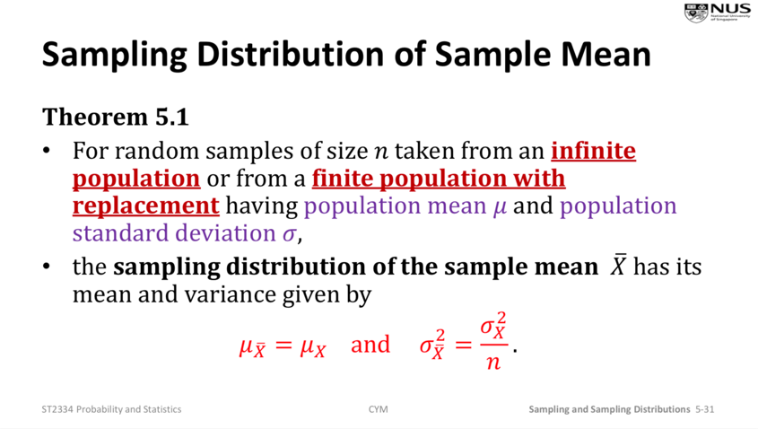

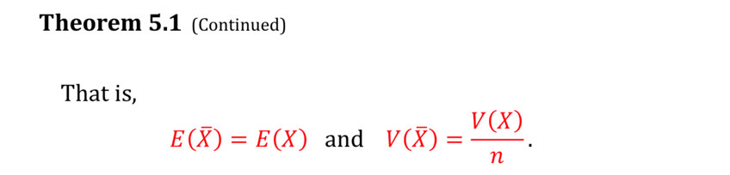

Law of Large Numbers

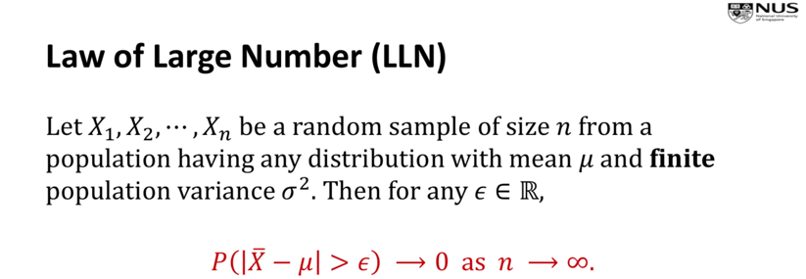

Central Limit Theorem (CLT)

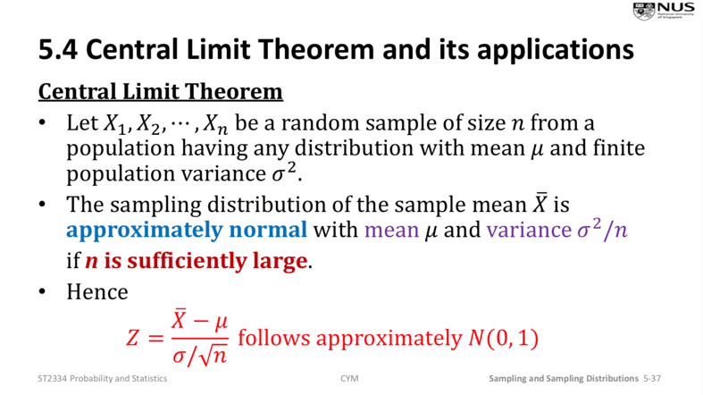n > 30 is considered sufficiently large

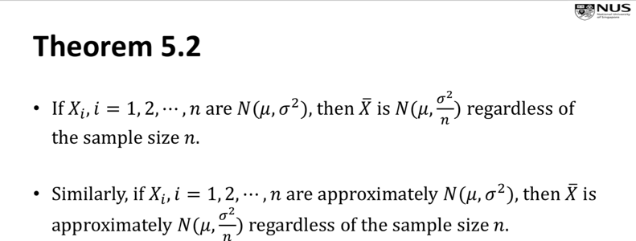

Sampling Distribution of Difference of Two Sample Means

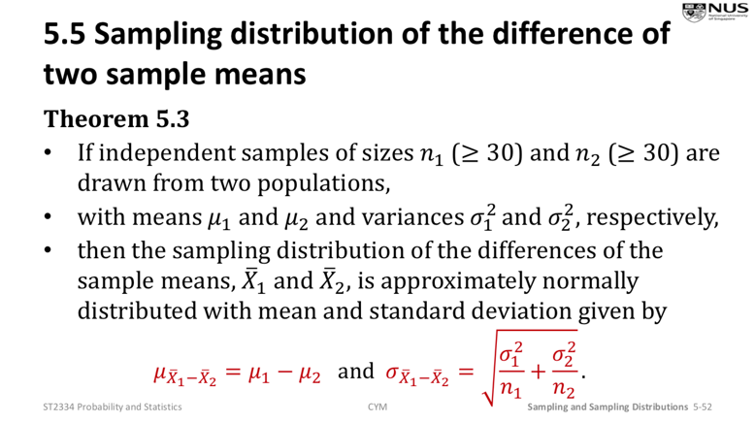

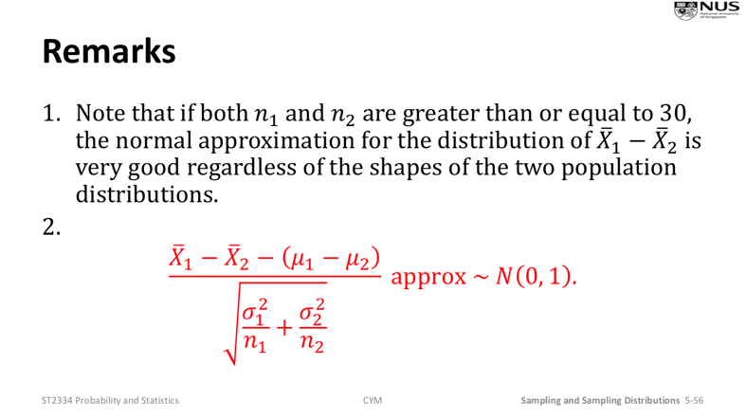

Chi-square Distribution

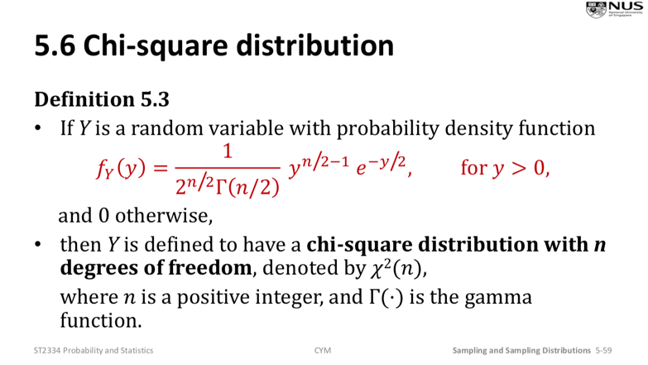

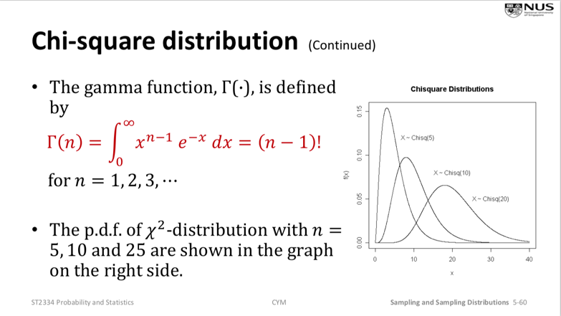

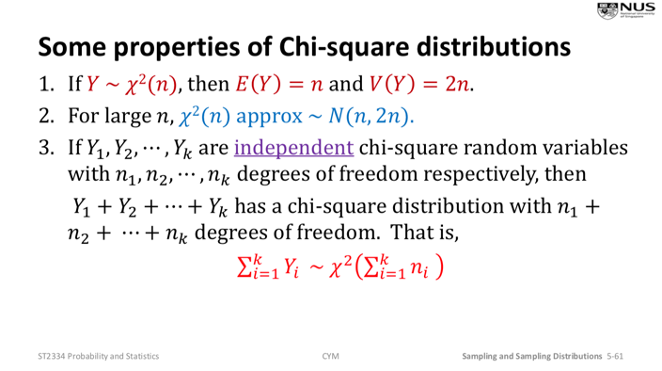

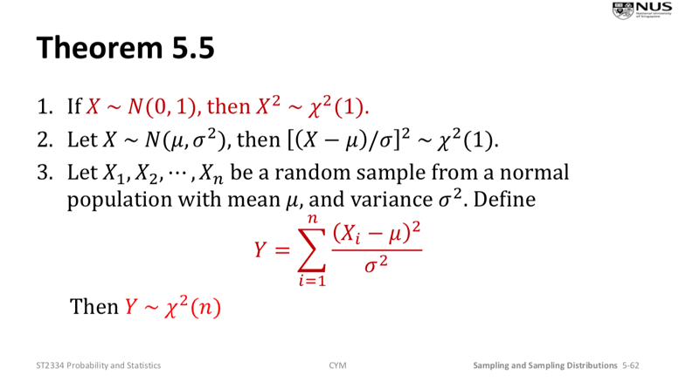

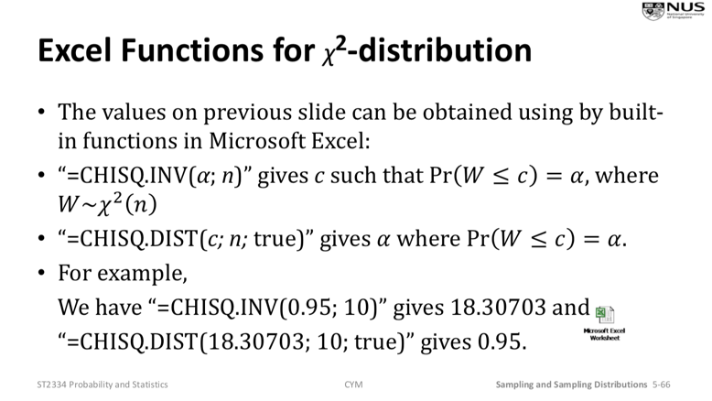

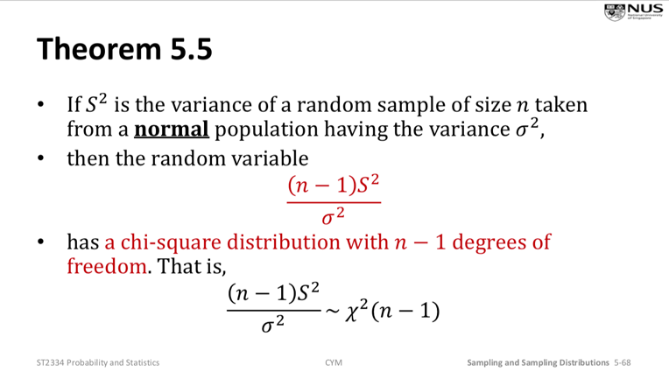

T-distribution

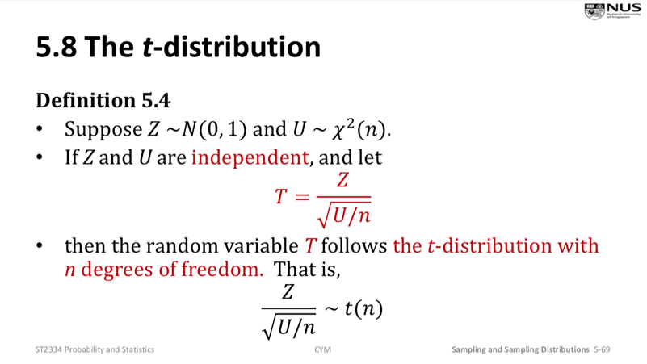

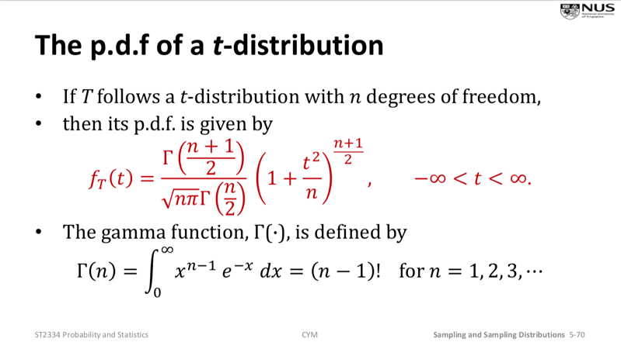

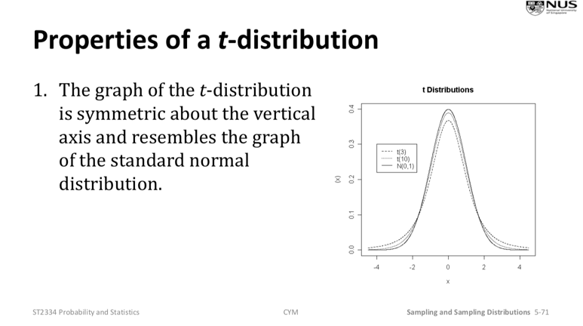

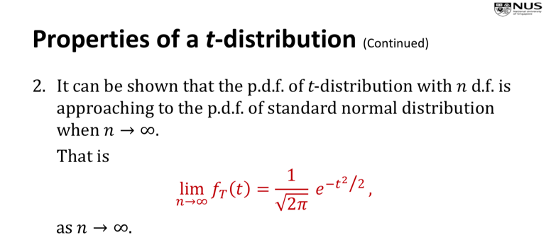

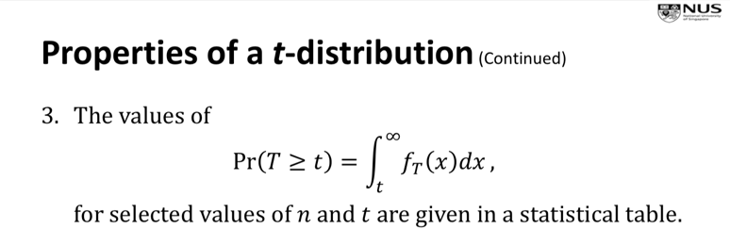

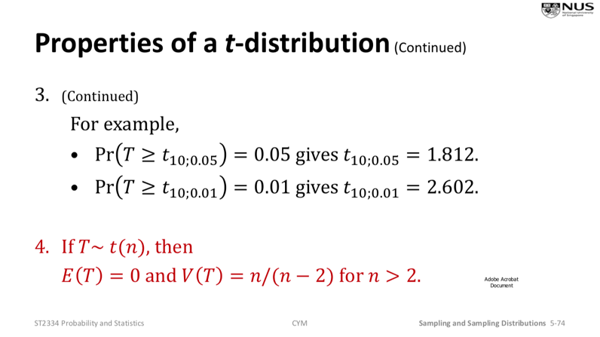

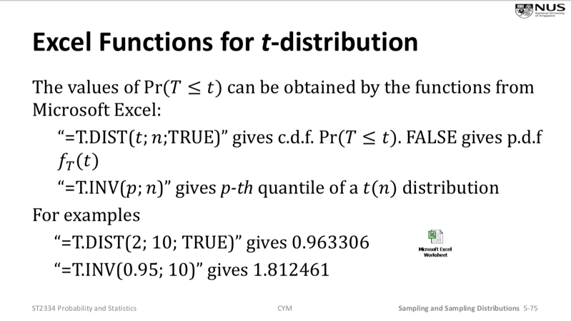

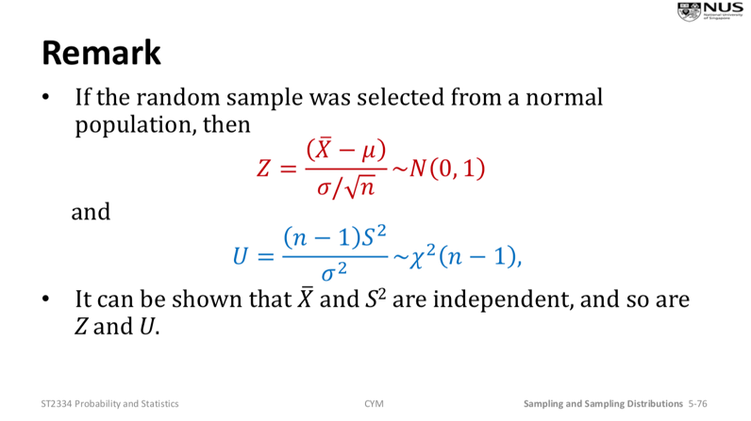

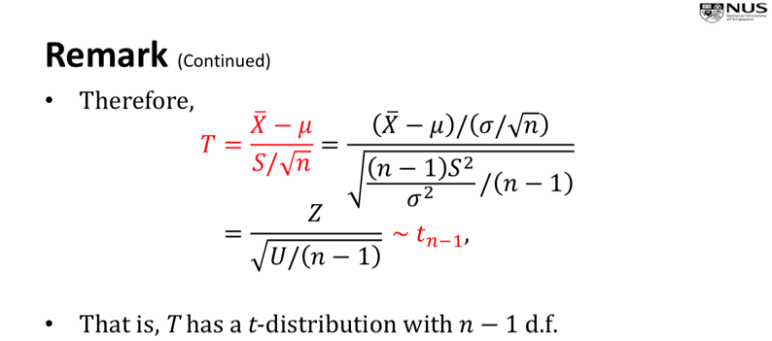

F-Distribution

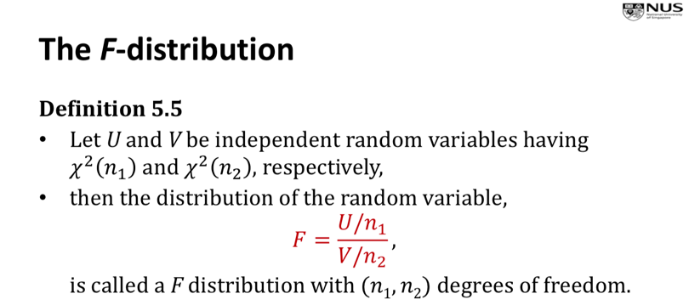

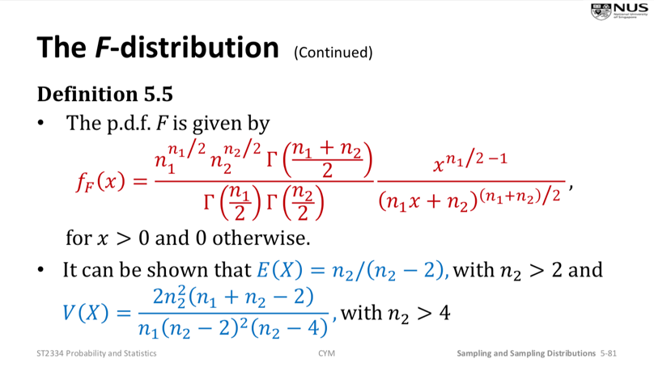

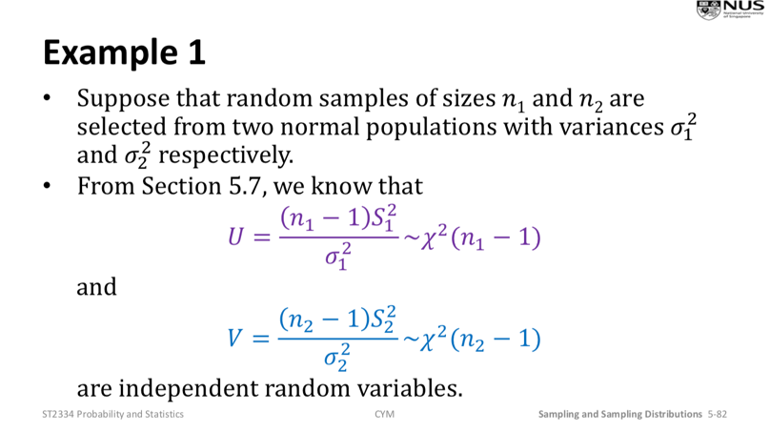

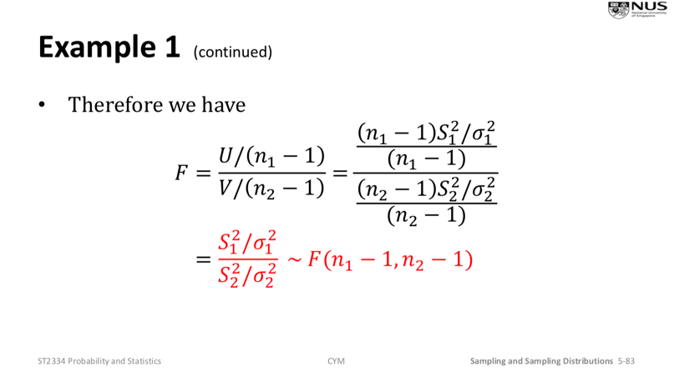

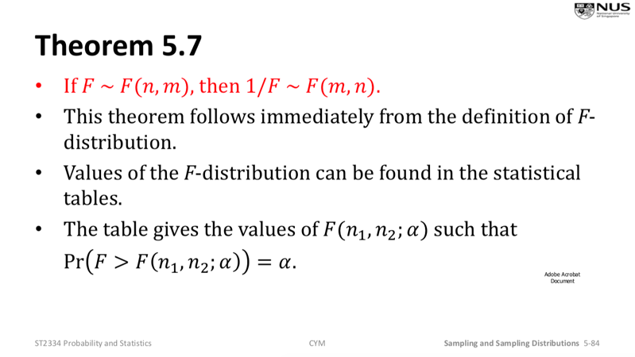\*\*\* F(a,b) = 1/F(b,a) (use this if cannot find probability in the f table)

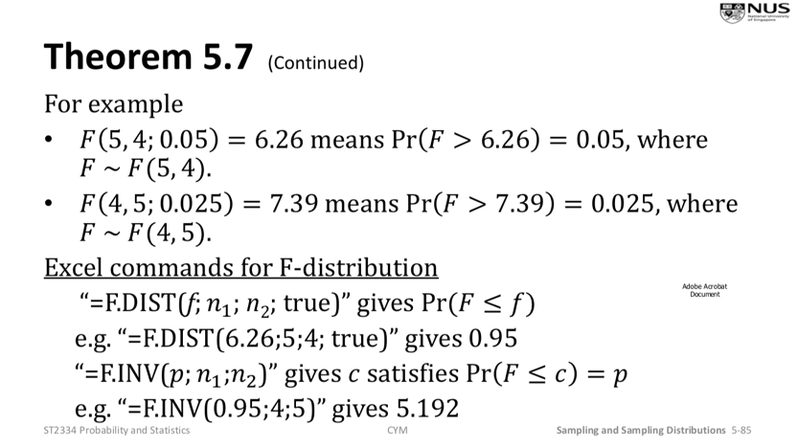

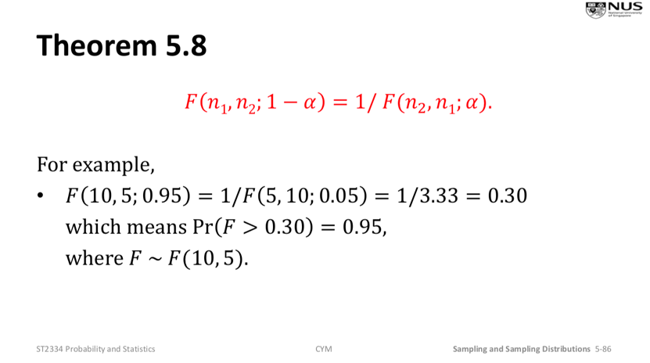

CHAPTER 6: ESTIMATION BASED ON NORMAL DISTRIBUTION

Point Estimation

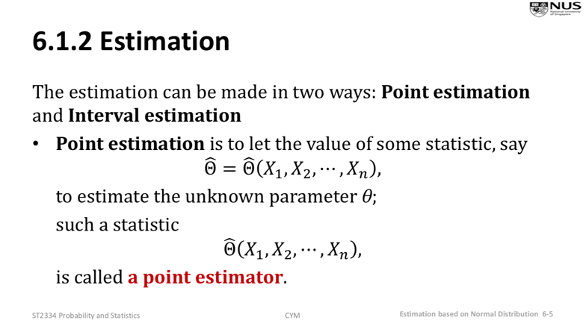

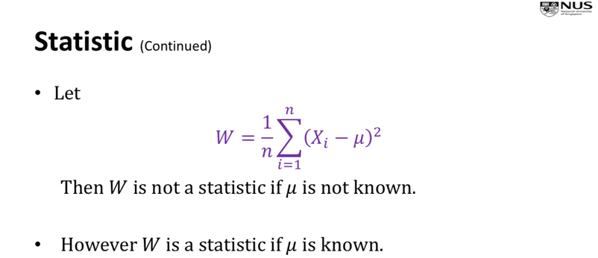

I.e. statistic must not have unknown parameters

Eg. sample mean is μ = 5, then point estimate of population mean μ is 5.

Interval estimation

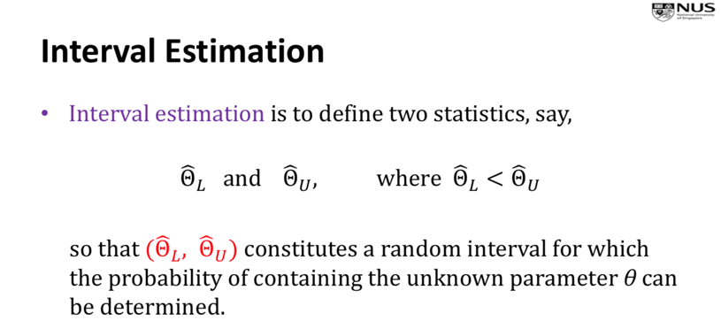

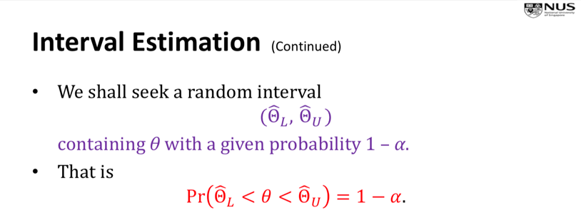

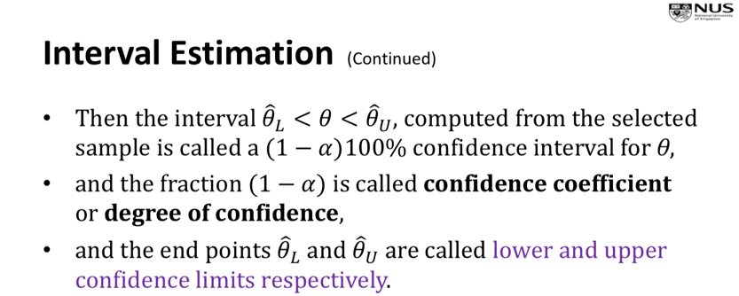

Unbiased estimator

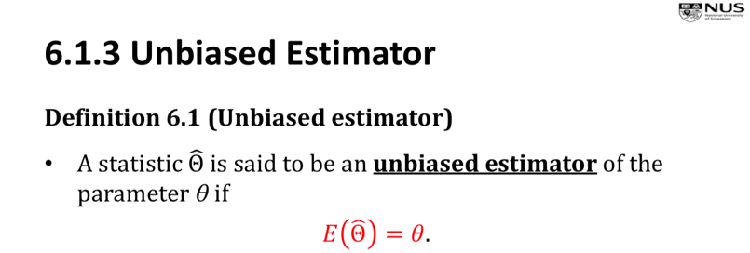

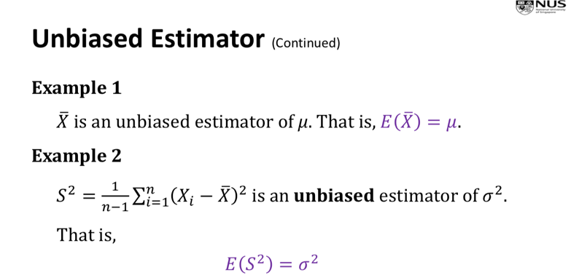

Confidence Interval for Mean – Known variance

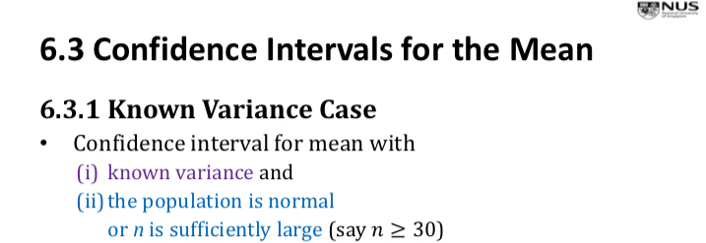

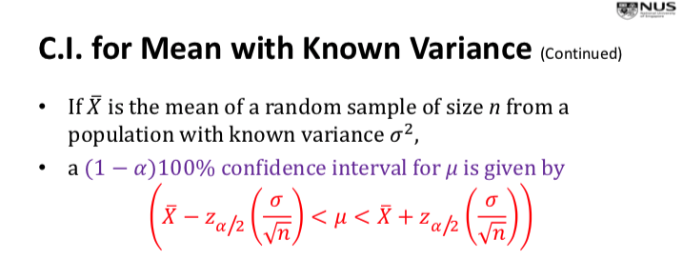

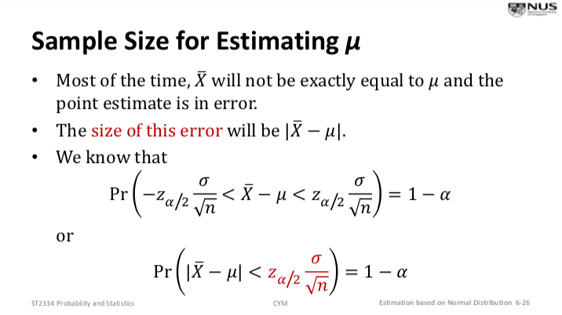

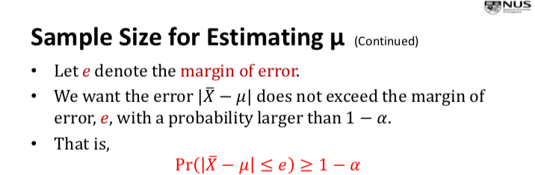

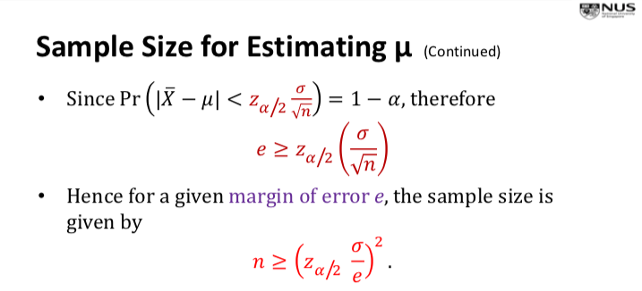

Confidence Interval for Mean – Unknown variance

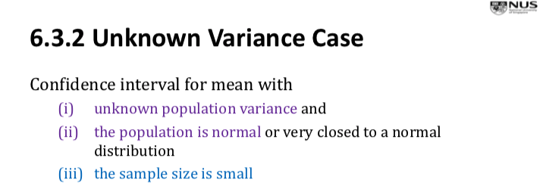

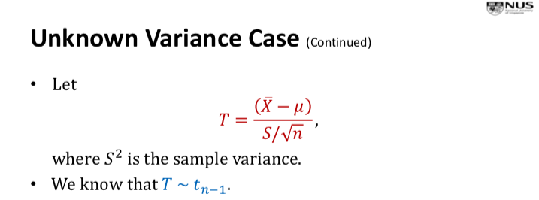

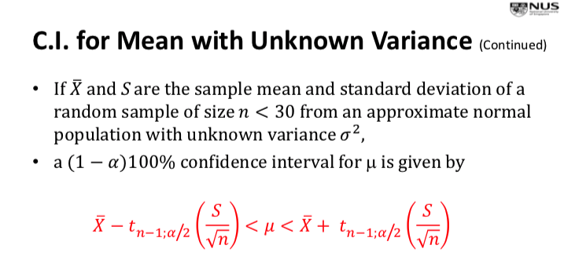

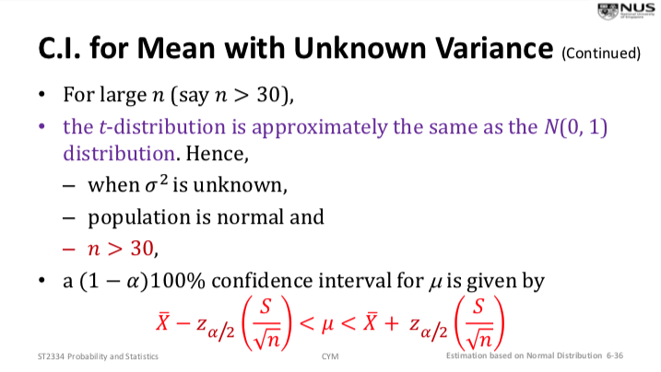

Note: 90% confidence interval is Z0.05 = 1.645 (z-value)

Note: 95% confidence interval is Z0.025 = 1.96 (z-value)

Note: 96% confidence interval is Z0.02 = 2.05 (z-value)

Note: 99% confidence interval is Z0.005 = 2.5728 (z-value)

Means, Pr( Z > 2.05) = 0.02, where Z ~ N(0, 1)

Note: n=7, 95% confidence interval is t6, 0.025 = 2.447 (t-value)

Note: n=21, 90% confidence interval is t20, 0.05 = 1.7247 (t-value)

Note: n= 10, 98% confidence interval is t9, 0.01 = 2.821 (t-value)

Confidence Interval for Difference between Two Means – Known variances

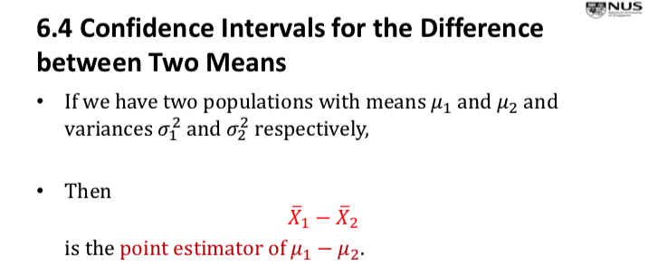

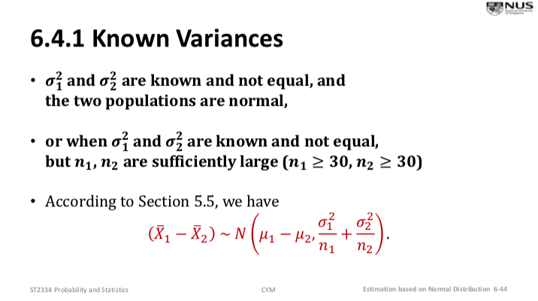

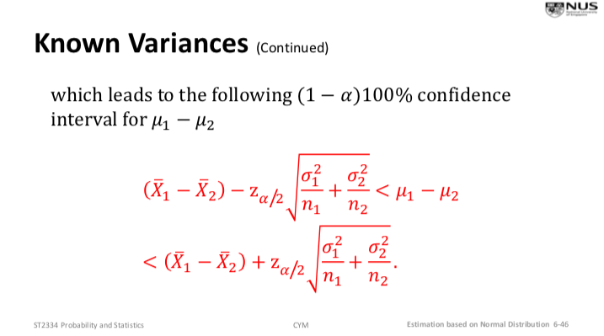

Confidence Interval for Difference between Two Means – Unknown variances

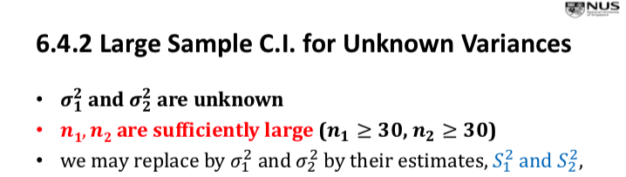

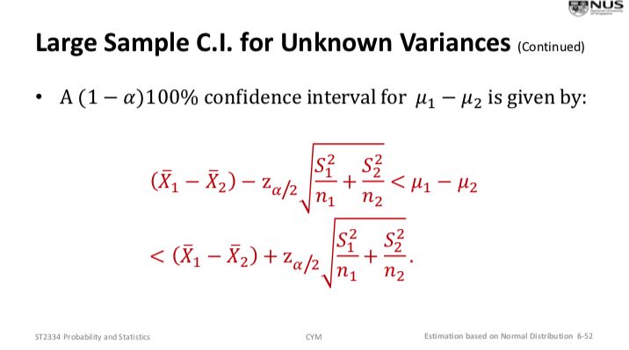

Note: question says “standard deviation” instead of “population standard deviation”

Confidence Interval for Difference between Two Means – Unknown but equal variances

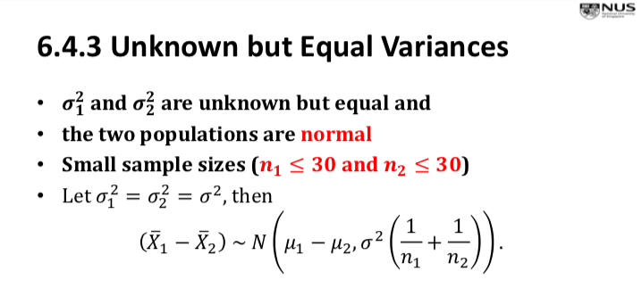

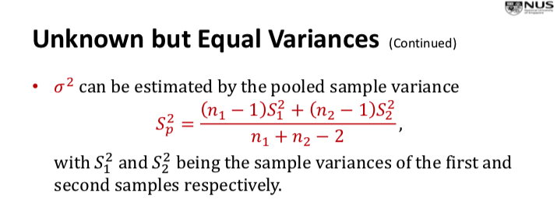

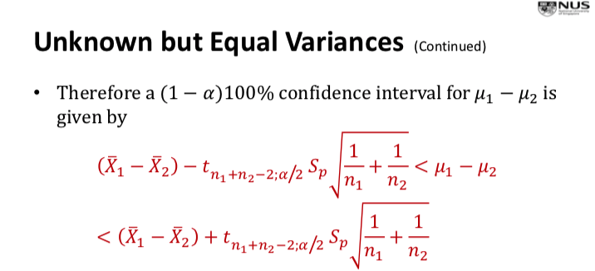

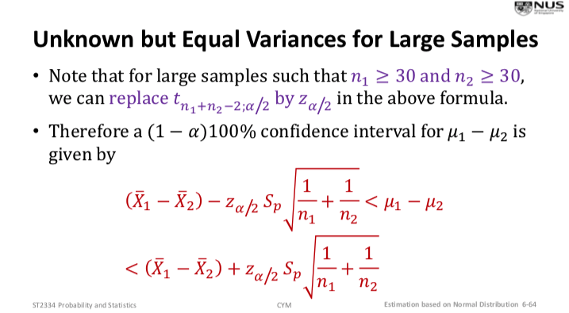

Confidence Interval for Difference between Two Means for Paired data

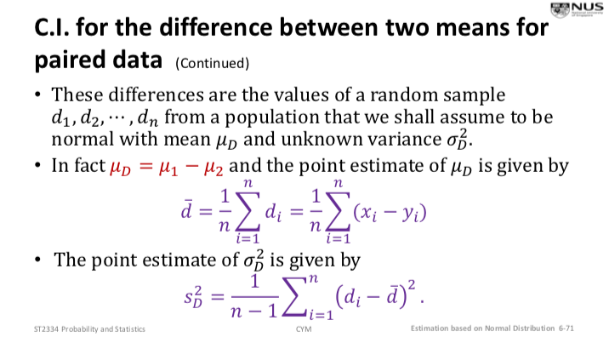

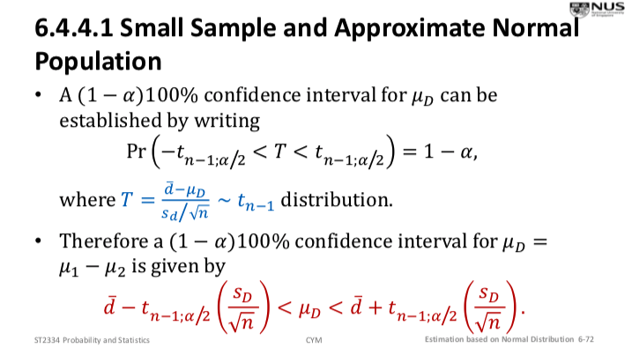

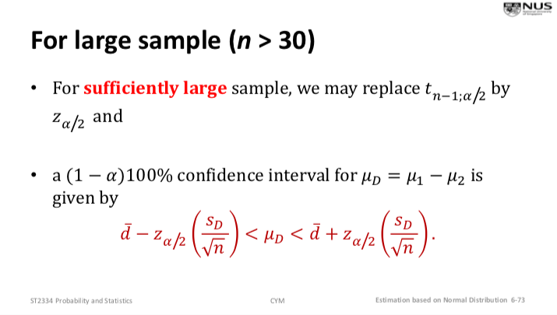

Confidence Interval for Variances and Ratio of Variances – Known Pop. Mean

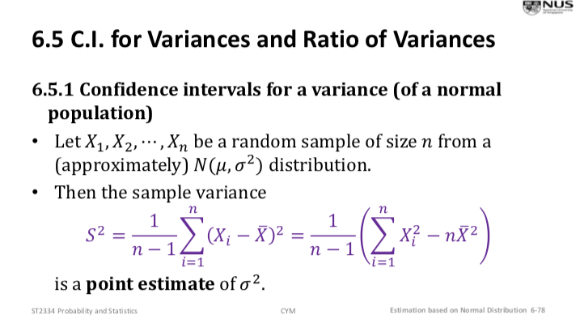

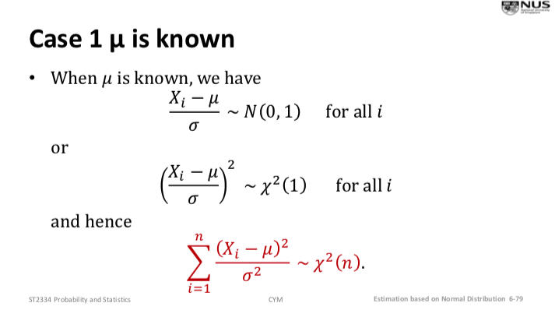

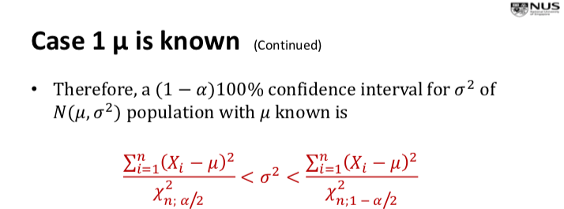

Confidence Interval for Variances and Ratio of Variances – Unknown Pop. Mean

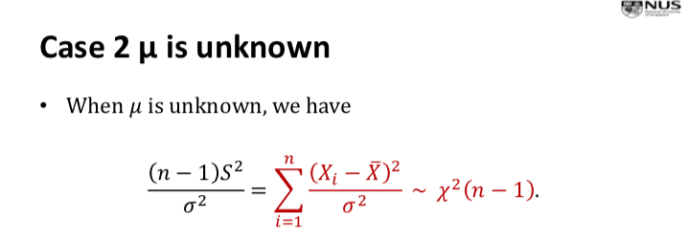

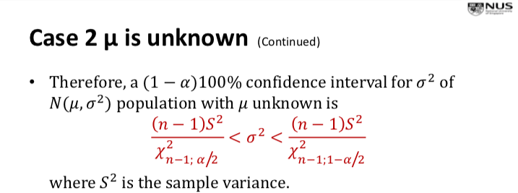

This is true for both small and large n

Confidence Interval for Ratio of Two Variances (Normal population) – Unknown means

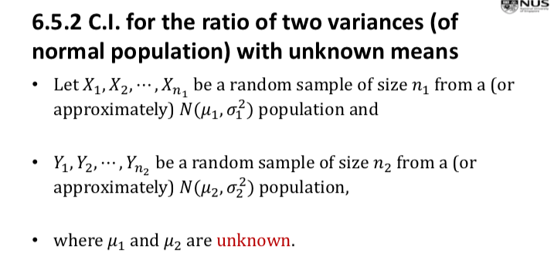

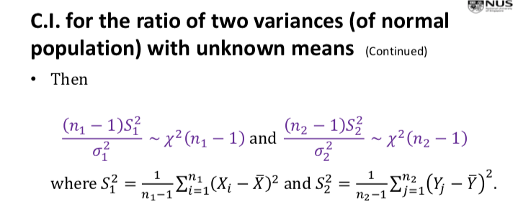

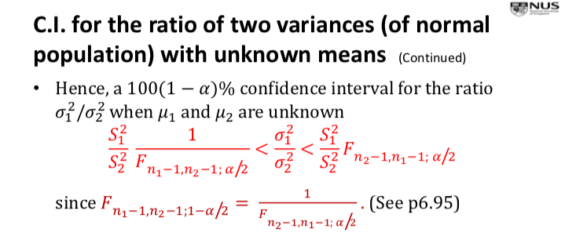

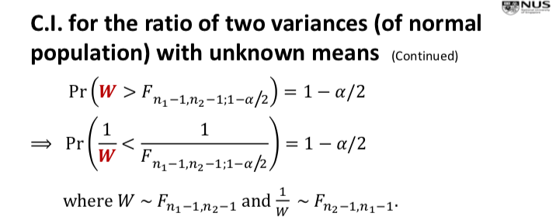

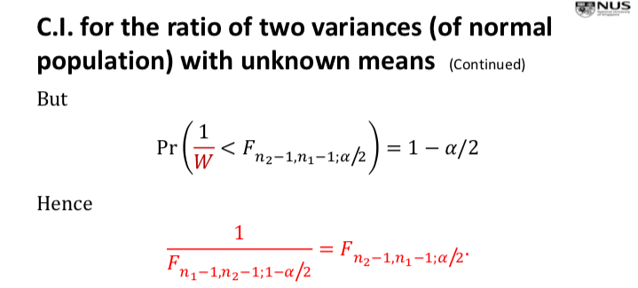

CHAPTER 7: HYPOTHESIS TESTING BASED ON NORMAL DISTRIBUTION

Statistical Hypothesis

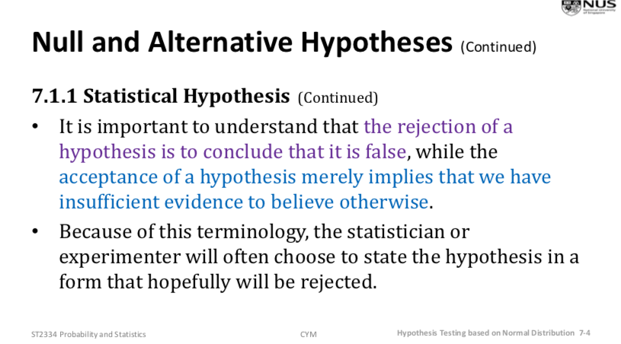

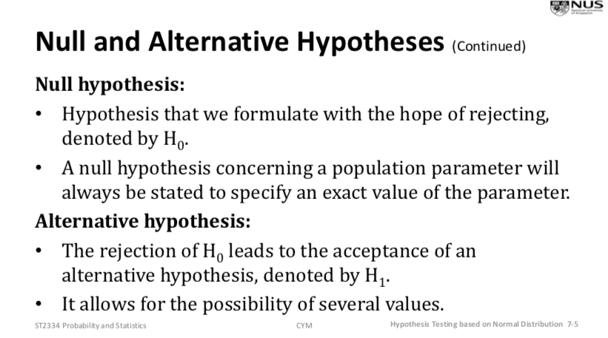

Types of Error (Type I Error and Type II Error)

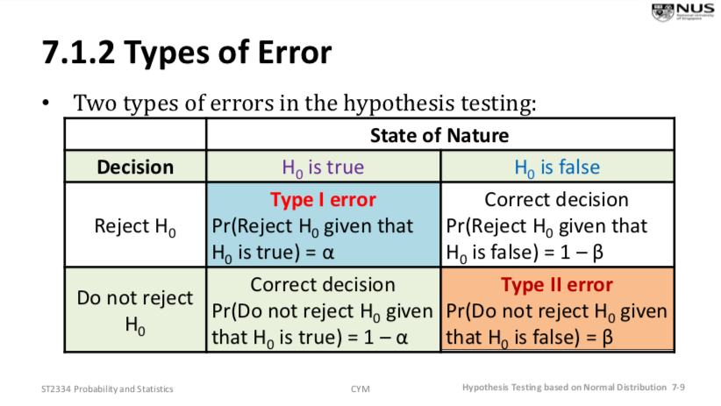

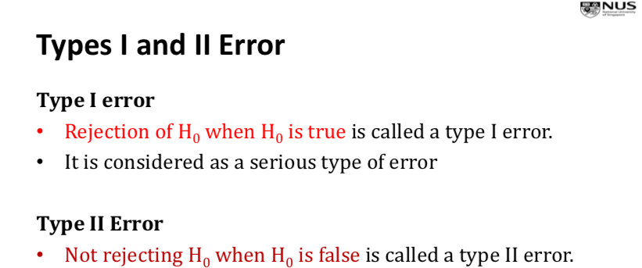

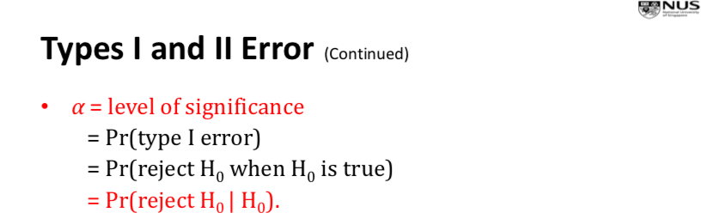

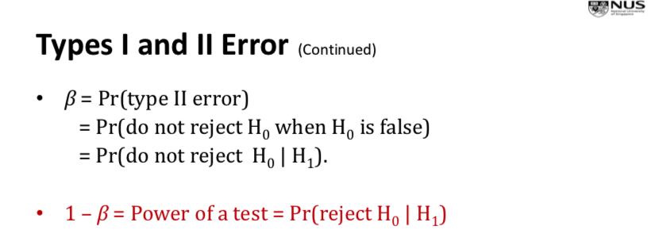

Note: Probability of committing a type II error (β) is impossible to compute, unless we have a specific alternative hypothesis, e.g. H0: p = ¼, H1: p = ½ (instead of p != ½)

Acceptance and Rejection Regions

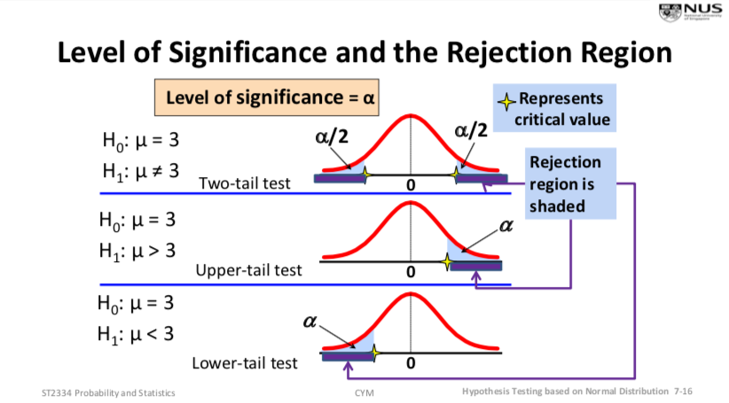

Note: Hypothesis testing may not just be about mean, can be probability (See L7, P17)

Hypothesis Testing on Mean – Known variance

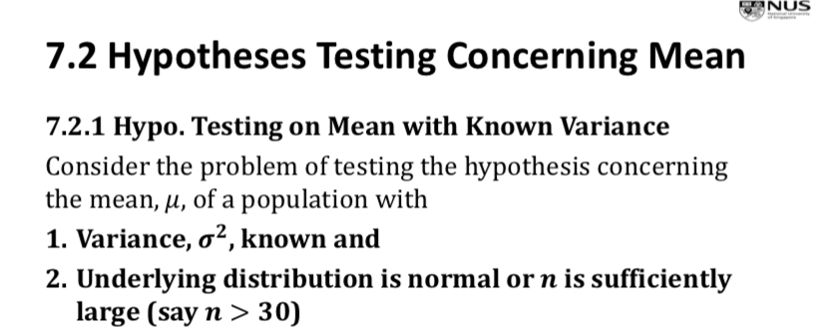

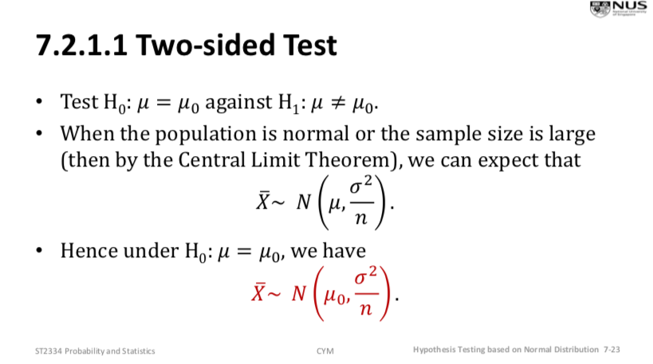

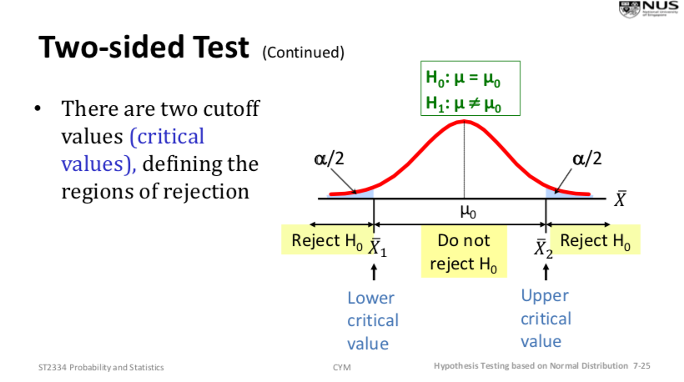 Critical value approach

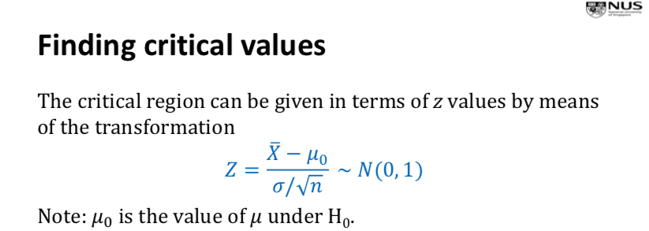



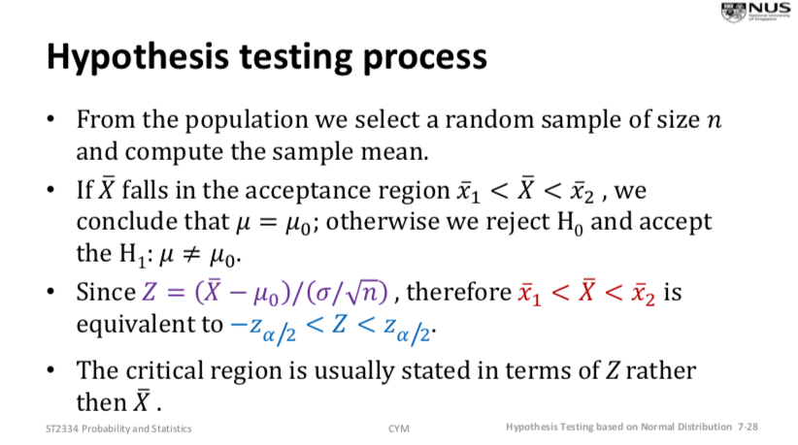

Equivalent to finding confidence interval

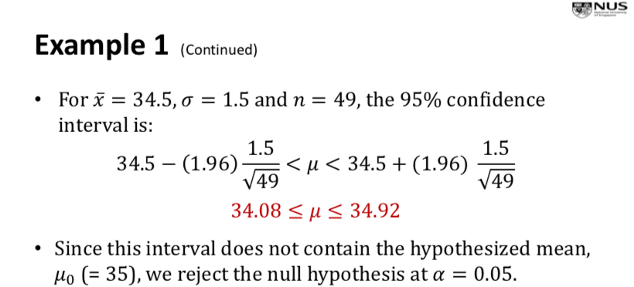

p-value Approach

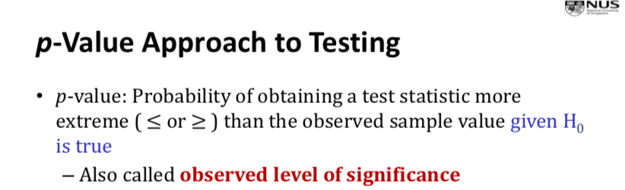

Note: level of significance is probability of rejecting null hypothesis, given it is true

p-value is a probability

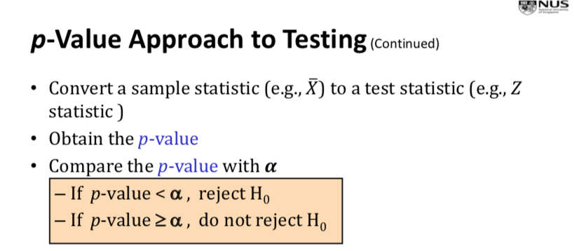

One sided Test

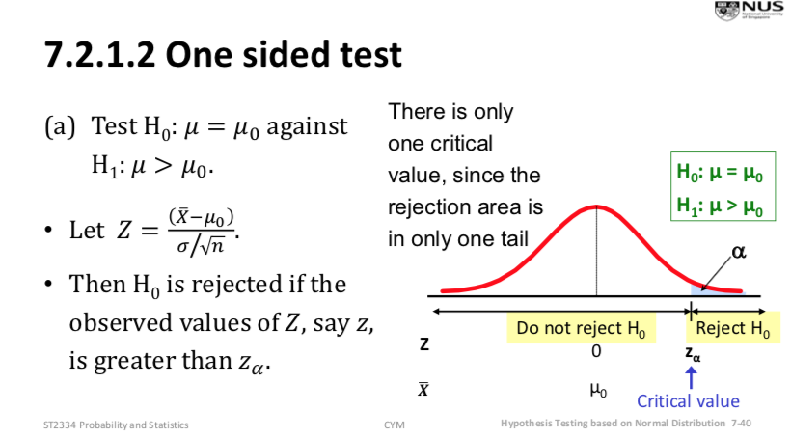

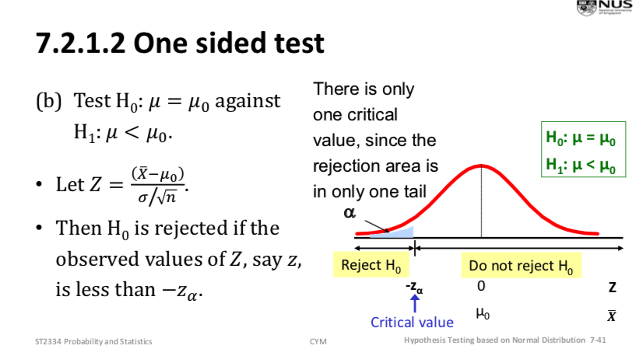

Hypothesis Testing on Mean with Unknown Variance

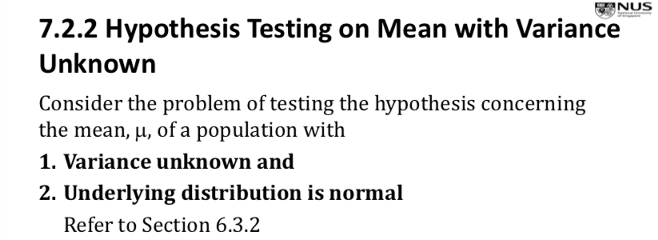

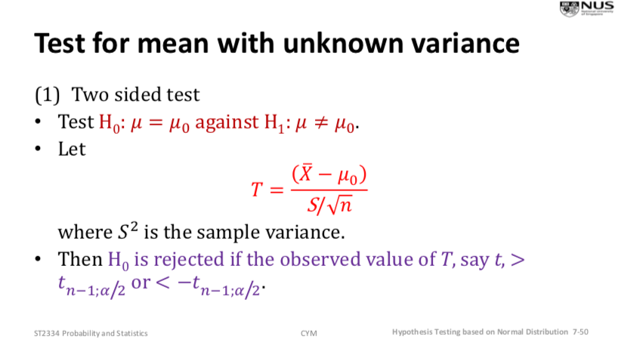

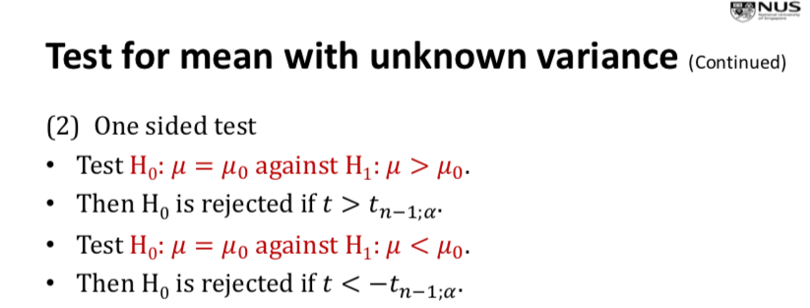

See L7 P55 for example of using t-table and t-value

Hypothesis Testing concerning Difference between Two Means – Known variances

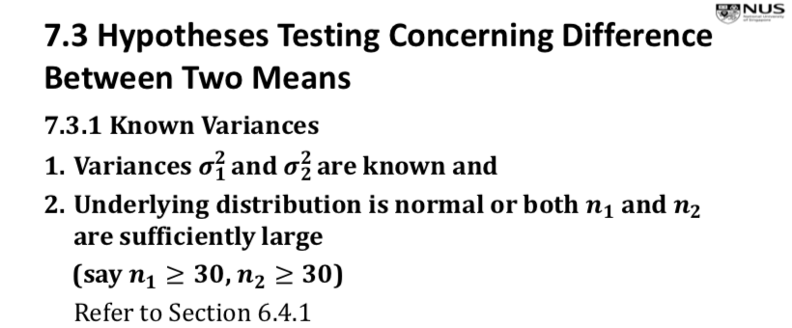

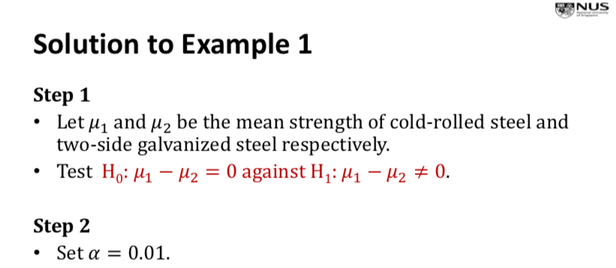

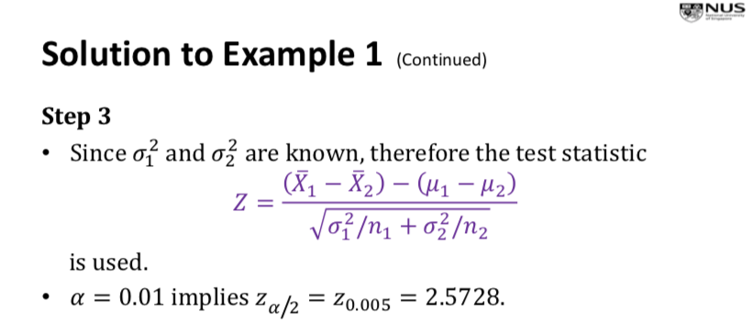

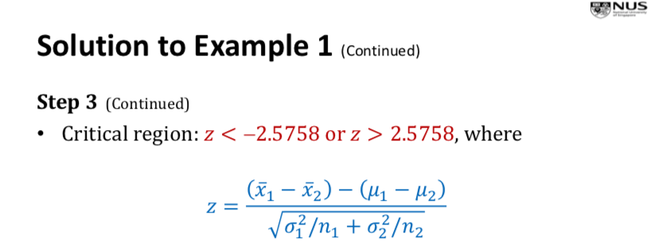

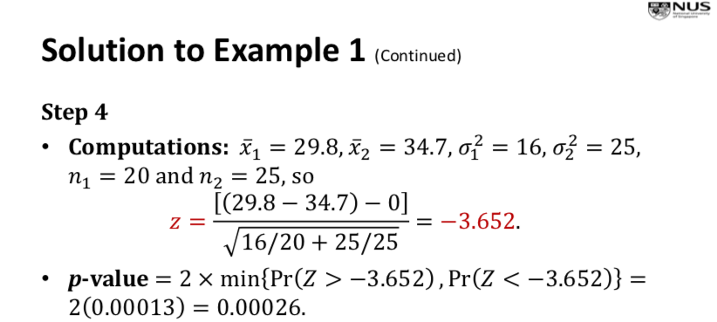

Hypothesis Testing concerning Difference of Two Means - Large Sample Testing with Unknown Variance

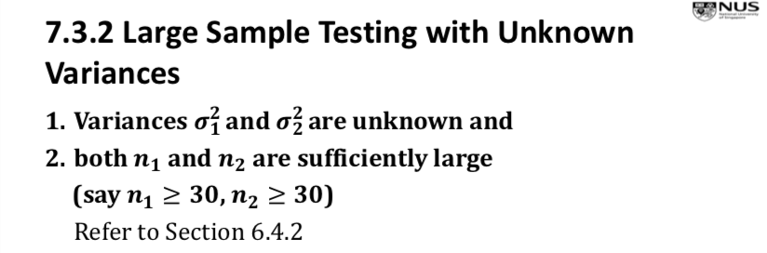

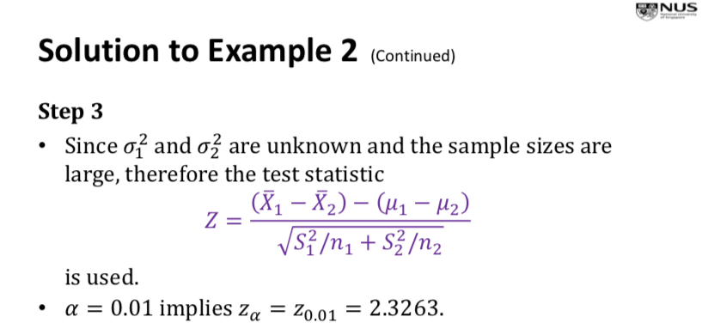

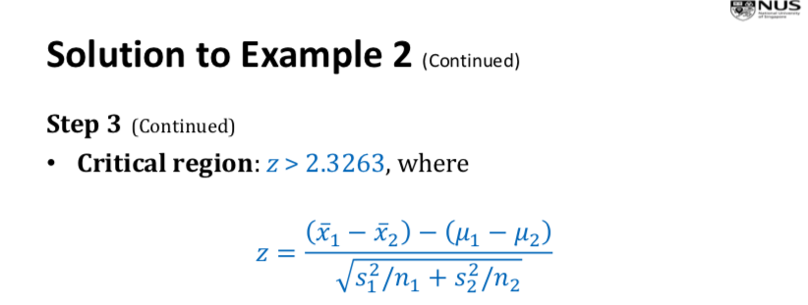

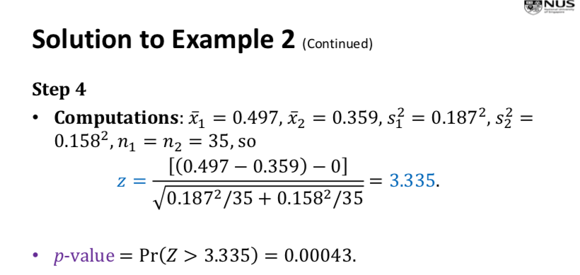

Hypothesis Testing concerning Difference of Two Means – Small sample size, unknown but equal variances

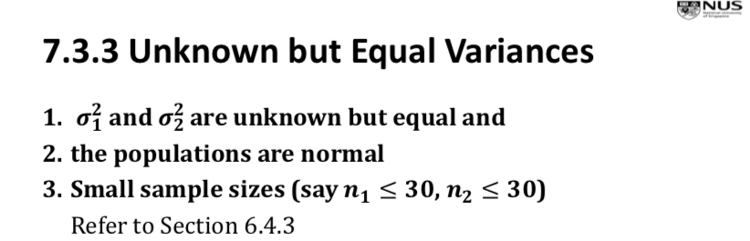

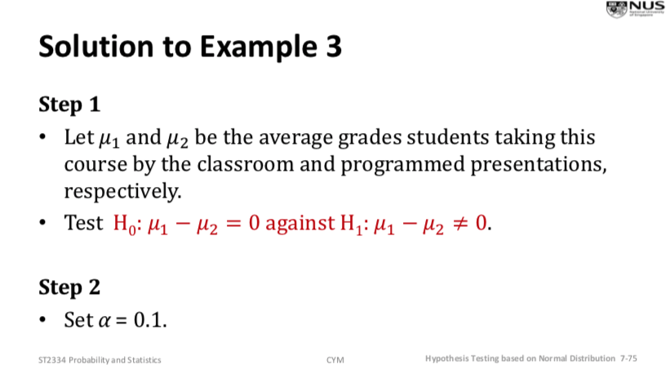

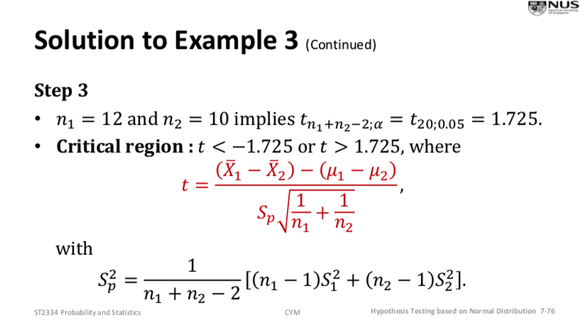

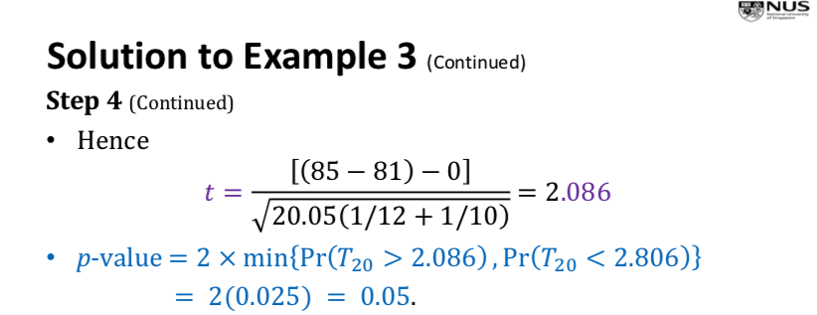

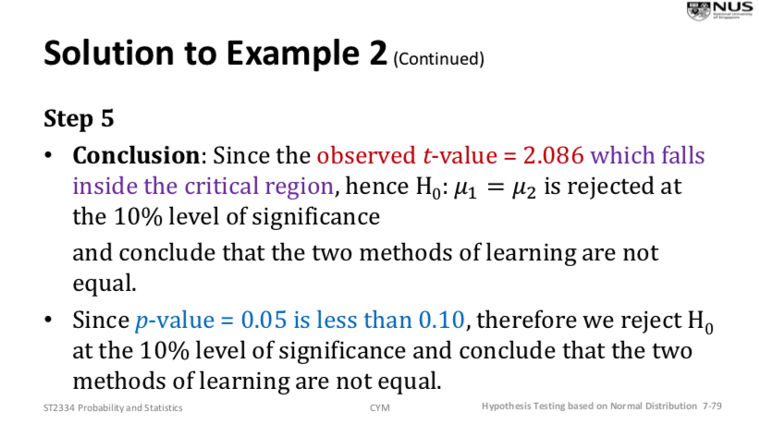

Hypothesis Testing concerning Paired Data

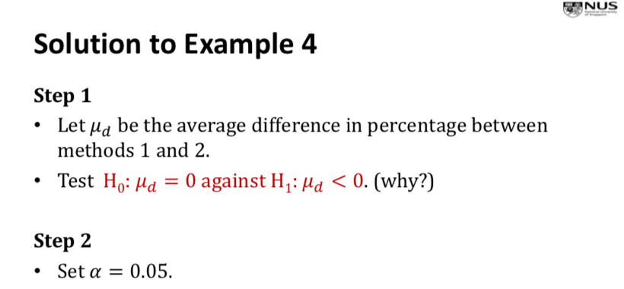

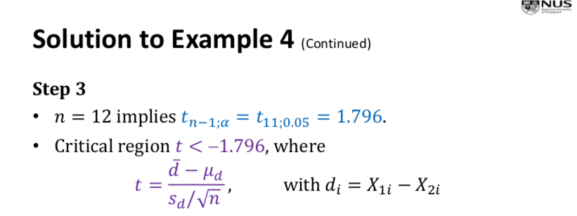

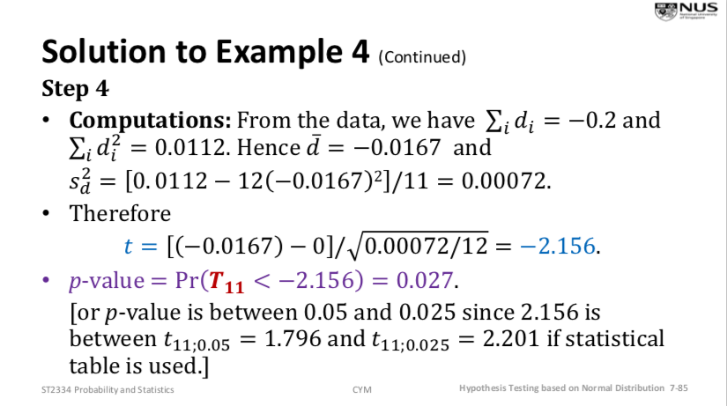

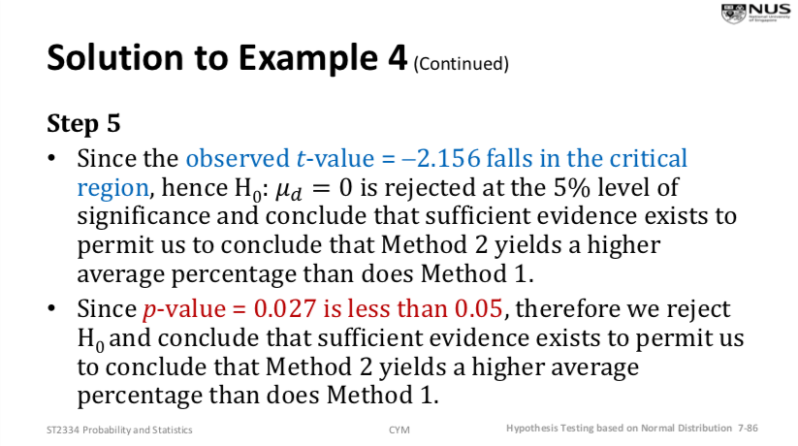

Hypothesis Testing concerning Variance – Assume underlying distribution is normal

(Eg. “Is the standard deviation > 0.9?”)

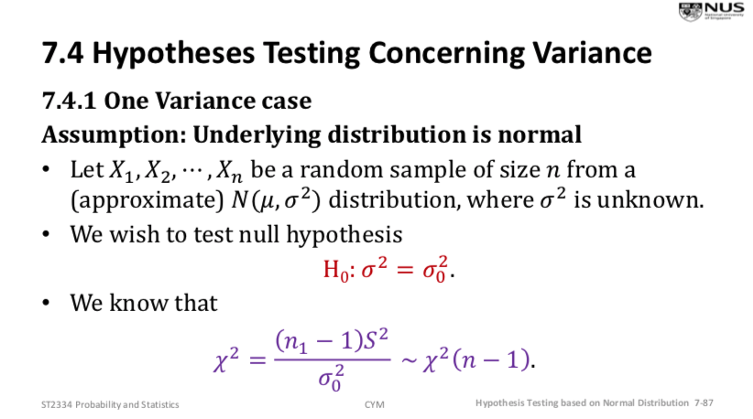

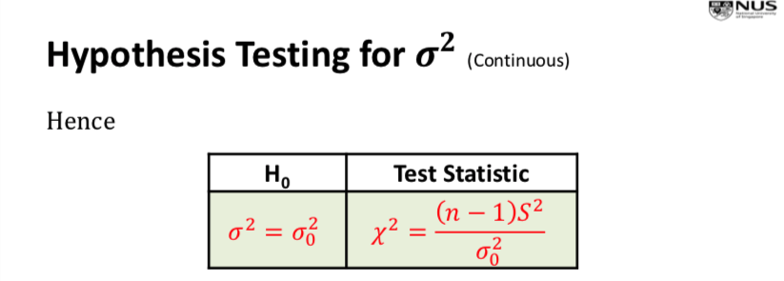

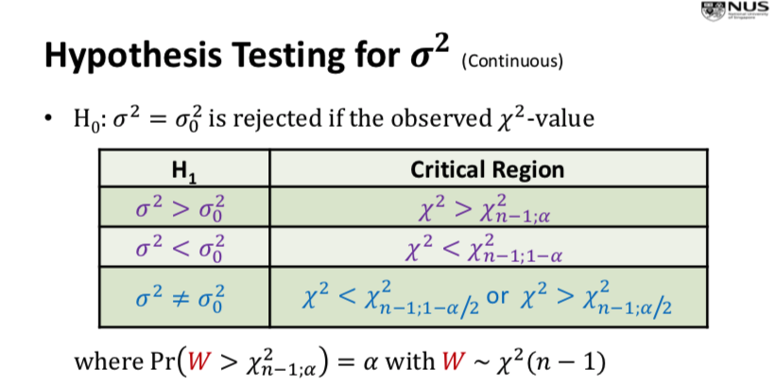

Hypothesis Testing concerning Ratio of Variance – Assume underlying distribution is normal

(Eg. “test the variances are equal”)

See L7 P103 for example on how to use F-statistic

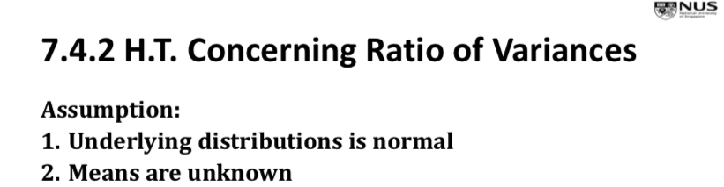

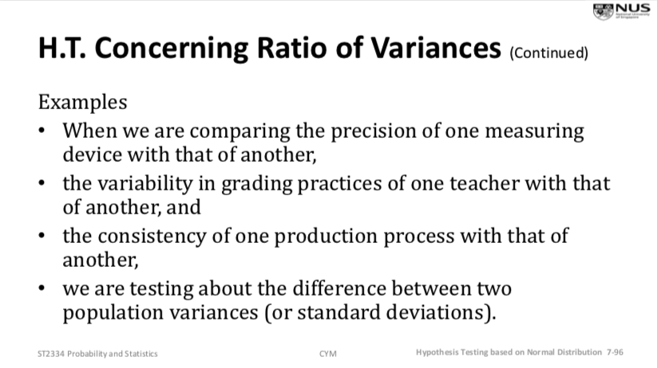

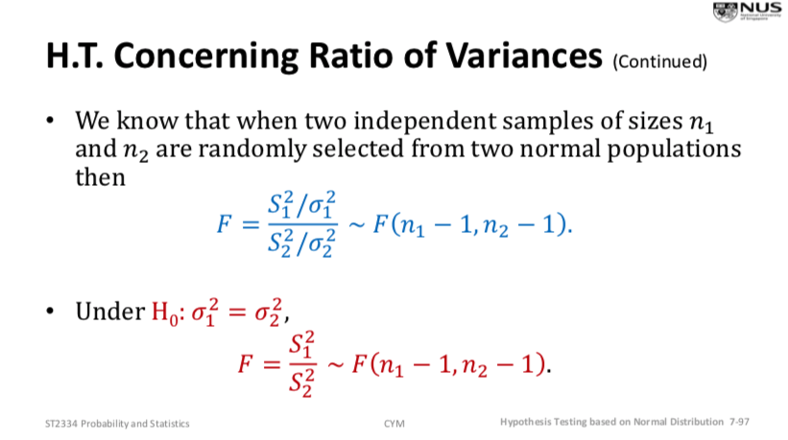

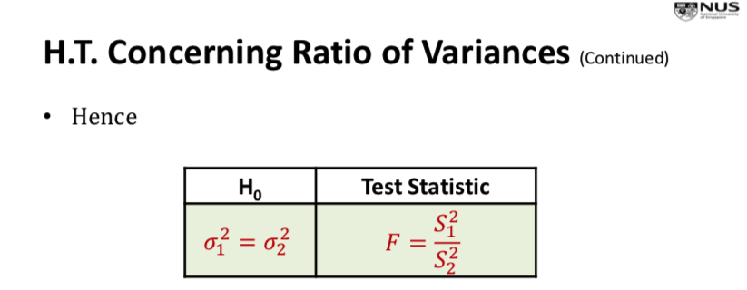

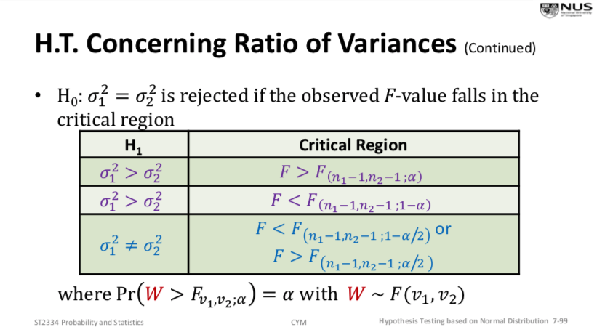

ADDITIONAL

Variance

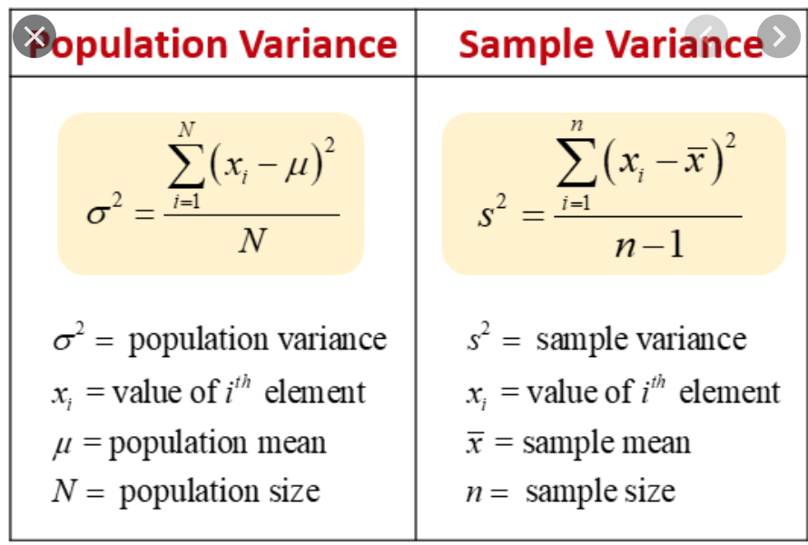

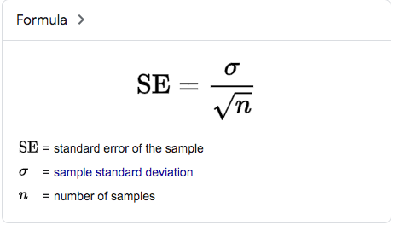 standard error